**To clarify how we determine if CGTC or CGCT is a subsequence of ACGCTAC, let's walk through the process step by step:**

**Example 1: Checking if CGTC is a subsequence of ACGCTAC**

We want to check if **CGTC** can be formed by removing some characters from **ACGCTAC** without changing the order of the remaining characters.

**Given DNA string**: **ACGCTAC**

**Target subsequence**: **CGTC**

1. Start at the beginning of **ACGCTAC** and look for the first character in **CGTC**, which is **C**.
   * The first **C** appears at position 1 (starting from 0). So we select it and move to the next character in **CGTC**.
2. The next character in **CGTC** is **G**.
   * Moving right from position 1, we find **G** at position 2 in **ACGCTAC**. We select it and move to the next character in **CGTC**.
3. The next character in **CGTC** is **T**.
   * Continuing from position 2, we find **T** at position 4 in **ACGCTAC**. We select it and move to the last character in **CGTC**.
4. The last character in **CGTC** is **C**.
   * From position 4, we find another **C** at position 6 in **ACGCTAC**. We select it.

Since we found all the characters **C, G, T, C** in the correct order, **CGTC** is a valid subsequence of **ACGCTAC**.

**Example 2: Checking if CGCT is a subsequence of ACGCTAC**

Now, let’s check if **CGCT** can also be formed by removing some characters from **ACGCTAC**.

**Given DNA string**: **ACGCTAC**

**Target subsequence**: **CGCT**

1. Start at the beginning of **ACGCTAC** and look for the first character in **CGCT**, which is **C**.
   * The first **C** appears at position 1. We select it and move to the next character in **CGCT**.
2. The next character in **CGCT** is **G**.
   * Moving right from position 1, we find **G** at position 2. We select it and move to the next character in **CGCT**.
3. The next character in **CGCT** is **C**.
   * From position 2, we find another **C** at position 3. We select it and move to the last character in **CGCT**.
4. The last character in **CGCT** is **T**.
   * From position 3, we find **T** at position 4. We select it.

Since we found all the characters **C, G, C, T** in the correct order, **CGCT** is also a valid subsequence of **ACGCTAC**.

**Key Idea**

A **subsequence** keeps the order of characters intact but allows skipping some characters. You go through the original string (here, **ACGCTAC**) and find each character of the target subsequence (like **CGTC** or **CGCT**) in order, skipping over other characters as needed.

**Let’s apply the Longest Common Subsequence (LCS) algorithm to the strings:**

* **X=ABCA**
* **Y=AAC**

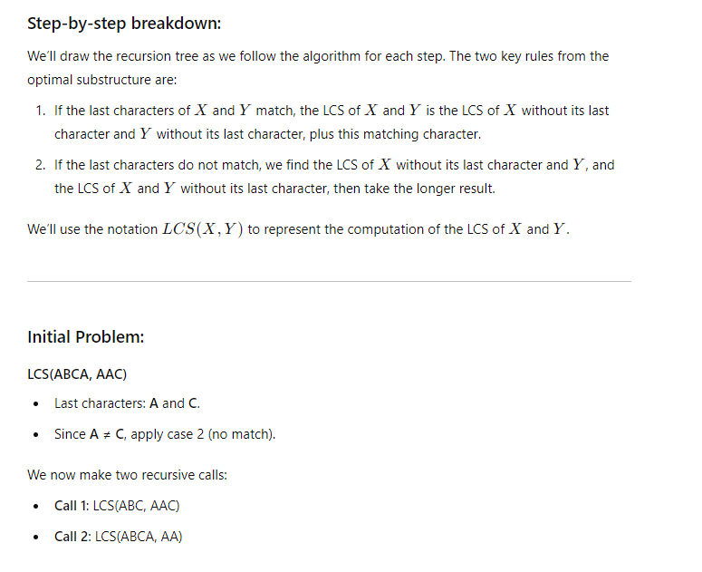

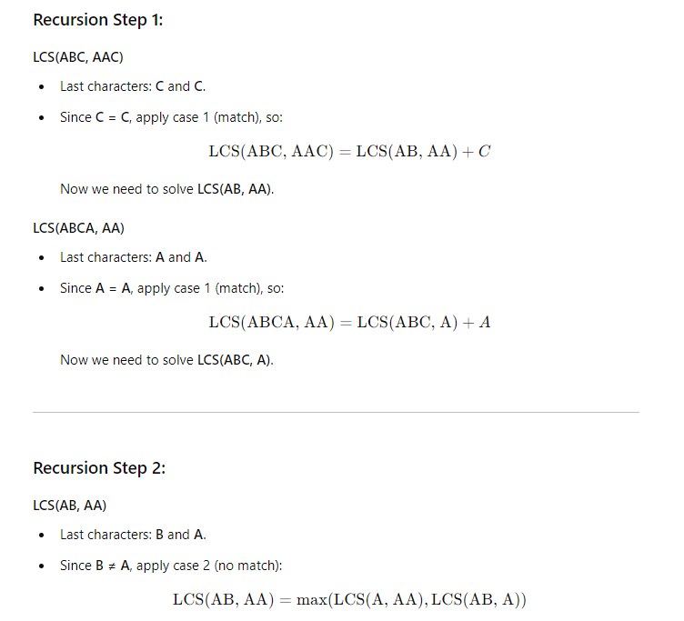

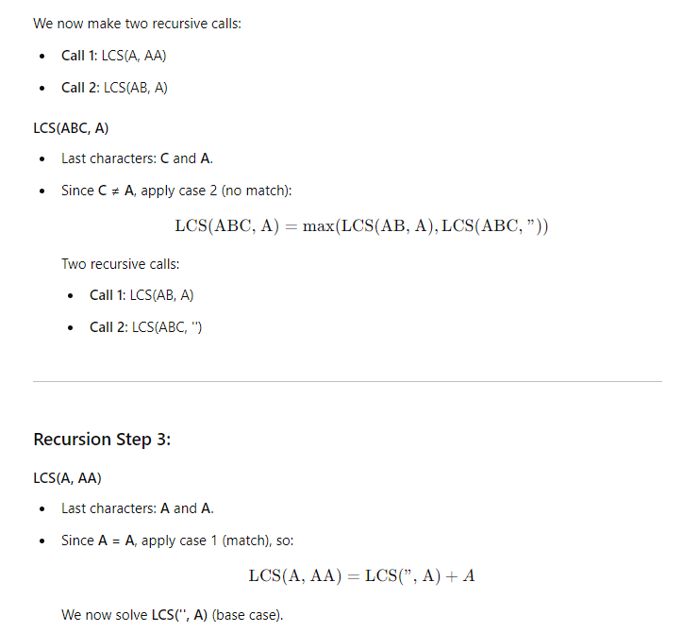

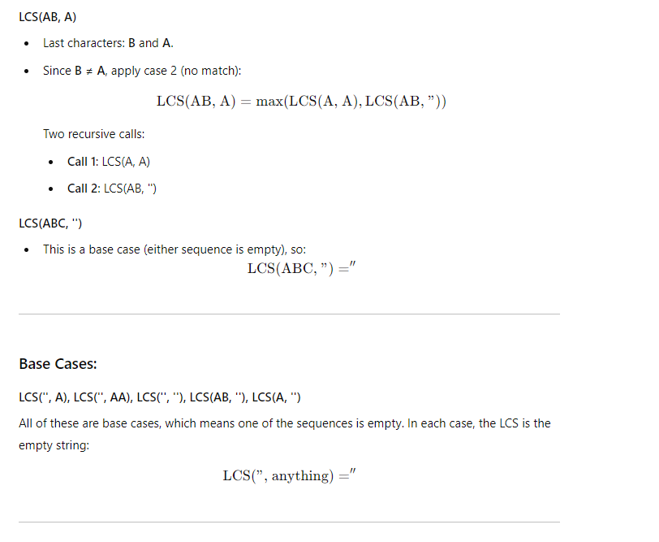

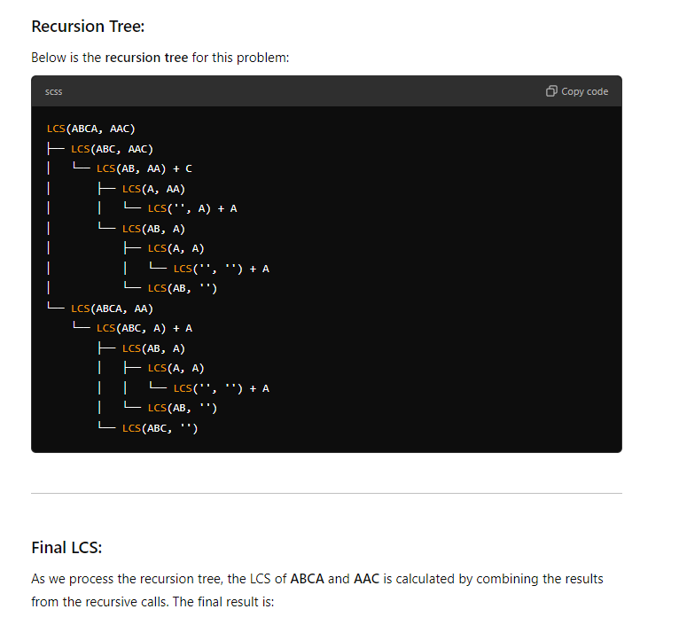



**Iteration advantages and disadvantages**

**Advantages of Iteration (Tabulation)**

1. **Improved Time Efficiency**: Iteration often avoids the overhead of recursive function calls, reducing the time complexity. In dynamic programming, tabulation iteratively fills up a table, providing a more efficient way to solve problems that could be costly with recursion.
2. **No Stack Overflow**: Since iteration doesn't rely on recursive calls, it avoids the risk of stack overflow, which can occur in recursion with deep recursion depth.
3. **Bottom-Up Approach**: Iterative tabulation uses a bottom-up approach, meaning it starts solving subproblems from the smallest to the largest. This ensures that all subproblems are already solved when needed for larger problems.

**Disadvantages of Iteration (Tabulation)**

1. **Higher Space Usage**: Tabulation typically requires storing a full table or array of subproblems, which may use more memory compared to the recursive (memoization) approach, where only partial subproblems are stored.
2. **Difficult to Implement for Complex Problems**: Iteration can be harder to implement for certain complex problems, where recursion may offer a more intuitive solution, especially for problems naturally expressed in a recursive manner (e.g., divide and conquer).
3. **Lack of Flexibility**: Iteration follows a fixed pattern (usually a loop structure) and is less flexible compared to recursion, which can easily adjust based on varying problem structures and conditions.

**Advantages and disadvantages of memoization**

**Advantages of Recursive (Memoization)**

1. **Reduced Time Complexity**: Memoization stores the results of previously solved subproblems, preventing redundant calculations and significantly reducing the time complexity, especially for problems like Fibonacci or dynamic programming.
2. **Intuitive for Divide-and-Conquer Problems**: Many complex problems are naturally recursive (e.g., tree traversal, divide-and-conquer algorithms). Memoization allows the problem to be broken down recursively in a way that mirrors the problem's structure, making the code easier to write and understand.
3. **Space Efficiency for Selective Storage**: Compared to tabulation, memoization only stores the results of subproblems that are needed, which can reduce space usage in some cases, particularly for problems with irregular subproblem dependencies.

**Disadvantages of Recursive (Memoization)**

1. **Stack Overflow Risk**: Since memoization relies on recursion, deep recursion can lead to stack overflow errors if the recursion depth exceeds the system's stack limit.
2. **Overhead of Recursive Calls**: Even with memoization, recursive function calls have their own overhead, including function call stack management, which can make the solution slower than an iterative approach in some cases.
3. **Complexity in Cache Management**: Memoization requires managing a cache (usually a hash map or array) to store results, which can add extra complexity. Moreover, improperly managing this cache can lead to memory inefficiencies or bugs.

**Let's break down these concepts to clarify their importance in greedy algorithms and how they ensure correctness:**

### 1. ****Greedy Choice Property****:

The **greedy choice property** states that the global optimal solution can be arrived at by making a series of locally optimal choices (i.e., making the best decision at each step without considering the overall problem).

* **Key Idea**: At each step, the algorithm makes a "greedy" decision that seems best for that moment.
* **Why it works**: If the problem exhibits the greedy choice property, the locally optimal solution at each step can lead to the global optimum. The choices made along the way never lead to a suboptimal outcome because at each stage, you're reducing the problem to a smaller instance of the same problem.

### Example of Greedy Choice Property:

* **Activity Selection Problem**: You always select the activity that ends the earliest. Since selecting activities that finish the earliest maximizes the time remaining for other activities, this local optimization leads to the global optimum.

**Proof of Greedy Choice Property**: To prove that a problem satisfies the greedy choice property:

* Assume that an optimal solution exists.
* Show that taking a greedy choice doesn’t prevent reaching this optimal solution.
* If this greedy choice doesn't interfere with future choices, then it’s possible to continue selecting locally optimal solutions and achieve the global optimal solution.

### 2. ****Optimal Substructure****:

A problem exhibits **optimal substructure** if an optimal solution to the overall problem contains optimal solutions to its subproblems.

* **Key Idea**: You can solve the problem by solving its subproblems optimally. In greedy algorithms, this means that the locally optimal choices build on each other to form an optimal global solution.
* **Why it works**: When a problem has optimal substructure, you can break it down into smaller parts. Solving these parts optimally leads to the solution of the overall problem.

### Example of Optimal Substructure:

* **Shortest Path Problem (Dijkstra’s Algorithm)**: The shortest path from node A to node D can be built from the shortest paths between intermediate nodes. If you know the shortest path from A to B and from B to D, then you can compute the shortest path from A to D.

**Proof of Optimal Substructure**: To prove optimal substructure, you need to:

* Show that breaking the problem into smaller subproblems and solving them optimally will give the overall optimal solution.
* This is usually demonstrated by induction, showing that for any subproblem, the greedy solution will lead to an optimal solution of the larger problem.

### 3. ****No Backtracking****:

Greedy algorithms make decisions that are final and **do not involve backtracking**. This means once a choice is made, it cannot be reversed, unlike approaches like dynamic programming, which may revisit subproblems.

* **Key Idea**: Greedy algorithms are fast and efficient because they don’t reconsider earlier decisions. This contrasts with other approaches that might backtrack or explore multiple possibilities before settling on the best option.
* **Why it works**: The problem’s structure ensures that once a locally optimal decision is made, it leads directly to the global optimal solution, so there’s no need to revisit earlier choices.

### 4. ****Proof of Correctness****:

To prove that a greedy algorithm is correct, you usually need to show two things:

* **Greedy Choice Property** holds: The algorithm can make locally optimal choices and still find the global optimum.
* **Optimal Substructure** exists: The solution to the overall problem can be built from optimal solutions to subproblems.

#### **Steps for Proof of Correctness:**

1. **Greedy Choice**:
   * Show that choosing the locally optimal solution at each step will lead to the optimal global solution.
   * Example (Activity Selection Problem): Prove that picking the activity that ends first leaves the maximum room for other activities, ensuring that no better solution could have been achieved by making a different choice at that step.
2. **Inductive Step (for Optimal Substructure)**:
   * Use induction to prove that for a given problem size, the greedy algorithm works correctly. Assume the algorithm works for smaller instances, then show that making the greedy choice and solving the remaining subproblem also gives the optimal solution.
   * Example (Fractional Knapsack): Prove that after picking the item with the highest value-to-weight ratio, the remaining problem is just a smaller instance of the same knapsack problem, and the greedy choice leads to the optimal solution.

### Example of Proof of Correctness: ****Huffman Coding****

1. **Greedy Choice Property**: The greedy choice is to combine the two characters with the smallest frequencies at each step. Prove that this step leads to the smallest possible encoding tree.
2. **Optimal Substructure**: Once the two smallest frequencies are combined, the problem is reduced to a smaller subproblem (with one less character), and the process repeats optimally for the reduced set.

### Conclusion:

* **Greedy Choice Property** ensures that local decisions lead to a global optimum.
* **Optimal Substructure** ensures that solving subproblems optimally leads to an overall optimal solution.
* **No Backtracking** is guaranteed as the problem structure ensures decisions made at each step are final and optimal, so there is no need to reconsider previous decisions.
* **Proof of Correctness** usually involves verifying that these properties hold through mathematical arguments or induction, depending on the problem.

**0/1 Knapsack Problem Explained with Greedy approach**

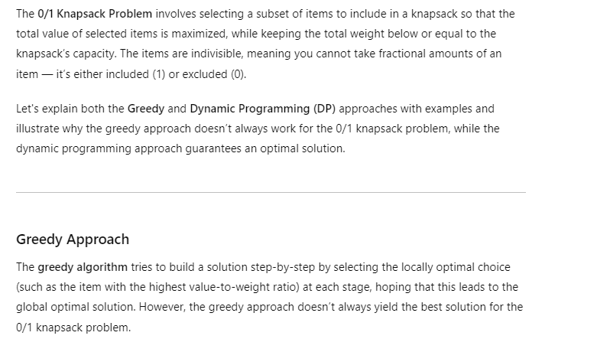

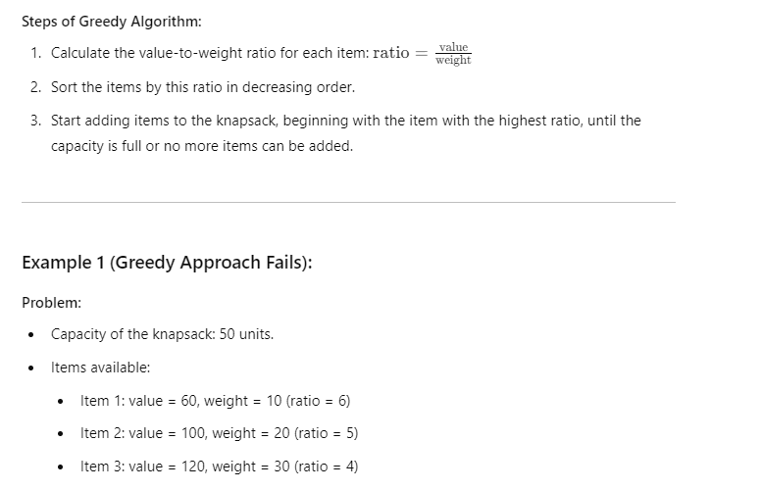

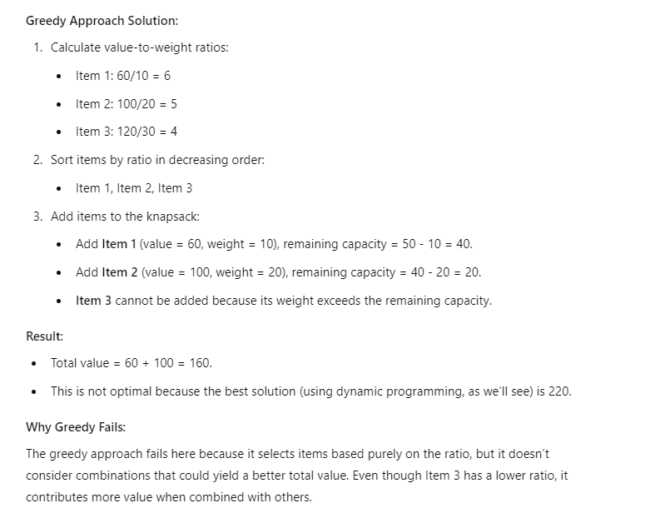

**fractional knapsack**

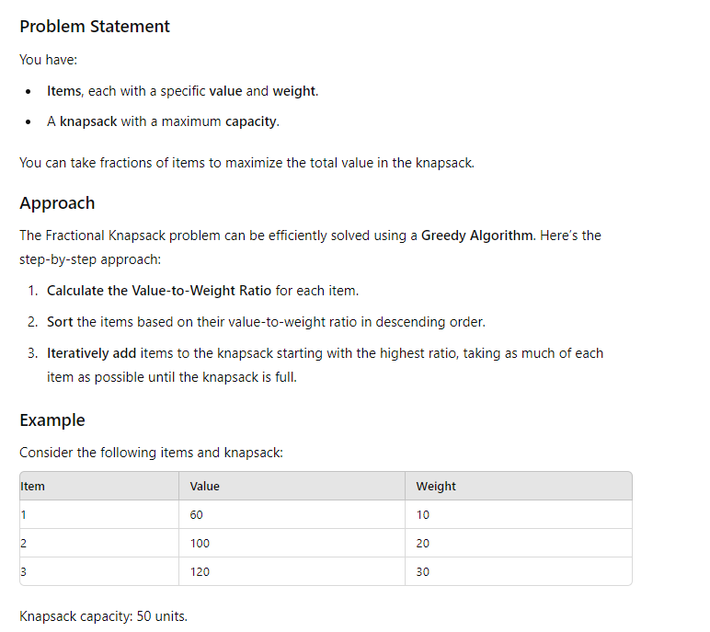

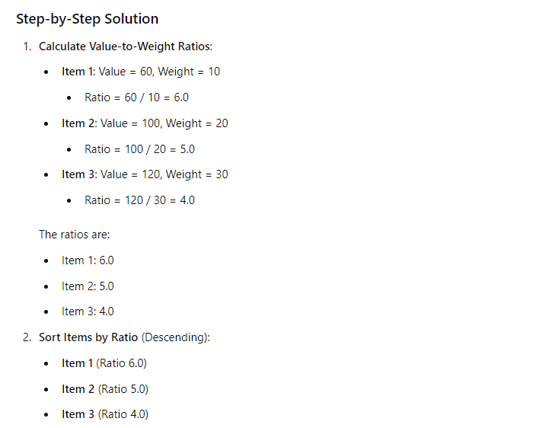

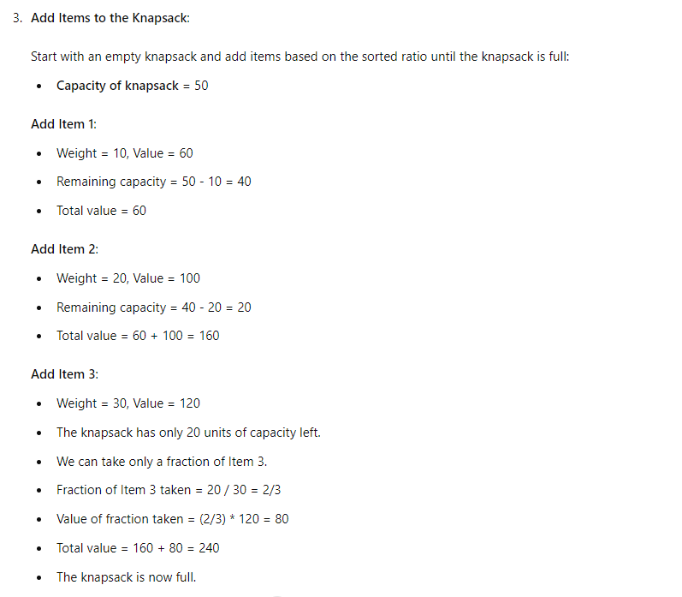

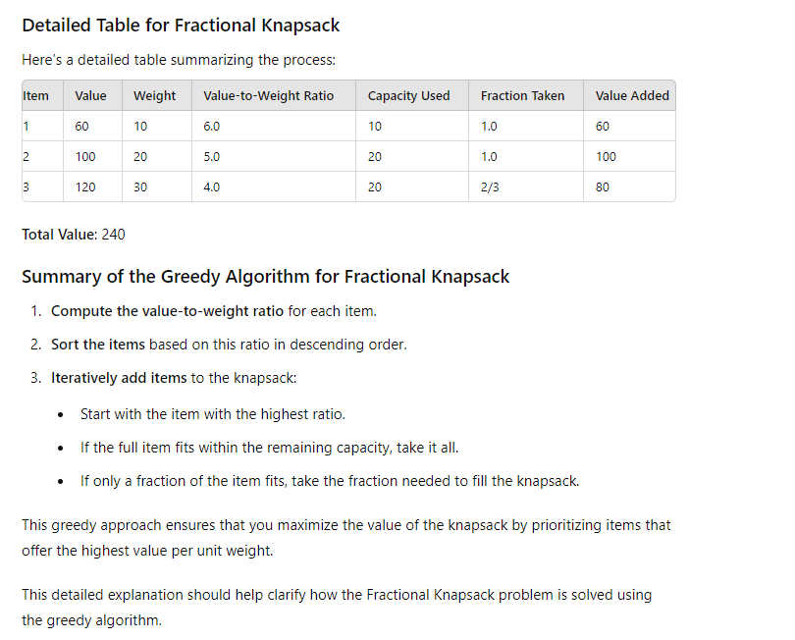

**Greedy Coin change problem**

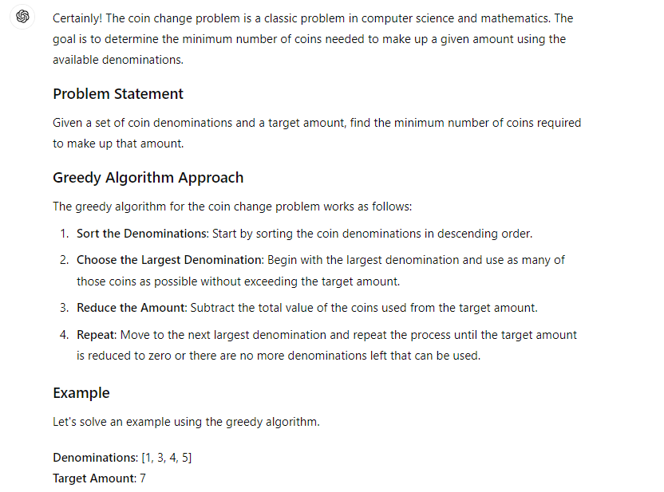

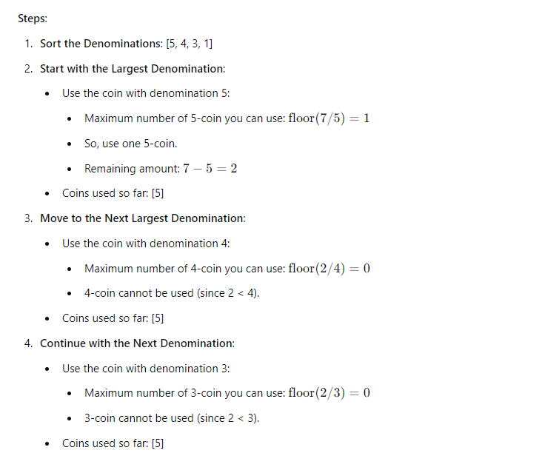

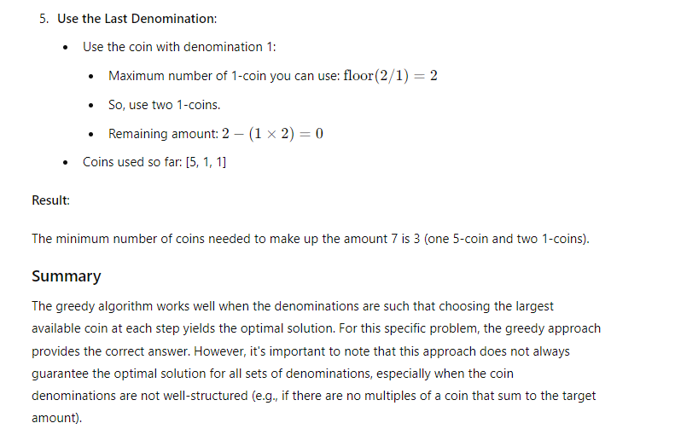

### ****Choosing the Best String-Matching Algorithm****

We are comparing two string-matching algorithms: the **Naive Algorithm** and the **Boyer-Moore-Horspool Algorithm**. To justify which one is better, we’ll examine the core differences, strengths, and weaknesses of each.

#### 1. **Naive String-Matching Algorithm**:

* **How it works**:
  + The algorithm slides the pattern over the text one position at a time.
  + At each position, it compares the entire pattern to the substring of the text starting at that position.
  + This comparison happens character by character.
* **Efficiency**:
  + **Worst-case time complexity**: O(m * n), where m is the length of the pattern and n is the length of the text.
  + This can be inefficient when dealing with long texts or patterns, because the algorithm checks every single character, even when a mismatch is found early in the comparison.
* **Use cases**:
  + The naive algorithm is simple to implement and works well for small texts and small patterns.
  + It doesn’t require preprocessing or extra memory, so it's useful in scenarios where memory is a concern and speed is not the top priority.

#### 2. **Boyer-Moore-Horspool Algorithm**:

* **How it works**:
  + This algorithm preprocesses the pattern and uses a **bad character rule** to shift the pattern by several positions whenever a mismatch occurs.
  + The bad character rule tells us how far to shift the pattern so we skip unnecessary comparisons. It skips as much of the text as possible when mismatches occur.
  + The shift table is built based on the characters in the pattern and helps skip sections of the text when a mismatch is found.
* **Efficiency**:
  + **Worst-case time complexity**: O(m * n) (similar to naive in the worst case).
  + **Average-case time complexity**: O(n), which makes it much faster in most real-world scenarios.
  + The pattern shift means that, on average, fewer characters are compared, making this algorithm much more efficient for larger texts.
* **Use cases**:
  + Best suited for large texts and patterns where performance is critical, such as DNA sequencing, searching in large documents, or logs.

#### **Conclusion: Boyer-Moore-Horspool is better**.

* **Justification**:
  + The **Boyer-Moore-Horspool Algorithm** is more efficient because it reduces the number of unnecessary comparisons.
  + Its ability to skip large portions of the text where mismatches occur allows it to operate in **O(n)** time on average, making it far more efficient for large inputs compared to the naive approach.
  + It’s the **best choice** when searching for a pattern in long texts or where the pattern and text length can vary greatly.

**LCS in iterative approach**

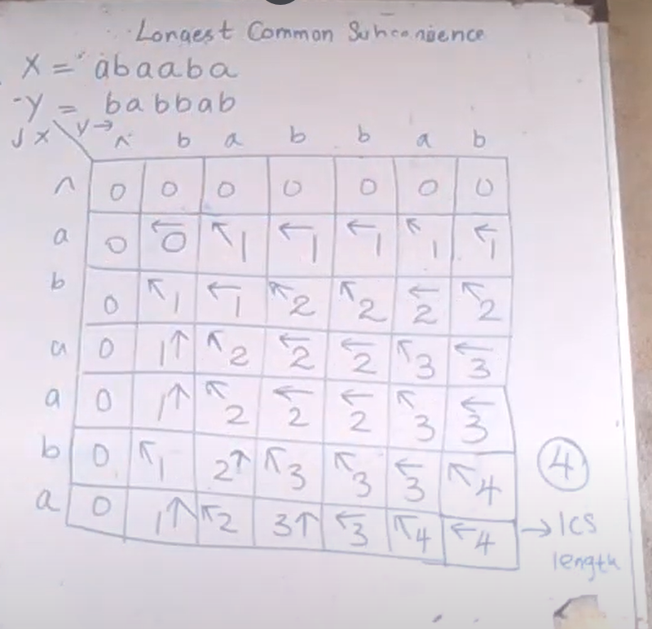

How draw this table:-

2nd row 2nd column slot eka fill karanakota balanna ona ekata adaala characters samanada kiyala.mekedi a and b thiyena nisa e slot ekata vam patte slot ekei above slot ekei max eka thamai ethenta danne.methanadi dekema 0 nisa adala slot ekata 0 dala eka gatta patta arrow ekakin danawa.methndi eka vam patten gatta vidiyata dala thinne.

2nd row 3rd column eka fill karana vidiya baluwoth ethendi e slot ekata adla characters dekama samanai(a and a).e nisa e slot eke diagonal slot eke(1st row 2nd column)thiyena index ekata ekak ekathu karala adala slot eka fill karanawa(0+1=1).arrow eka e patten apu nisa diagonal side ekata danawa.

LCS length is 4-last row last column slot

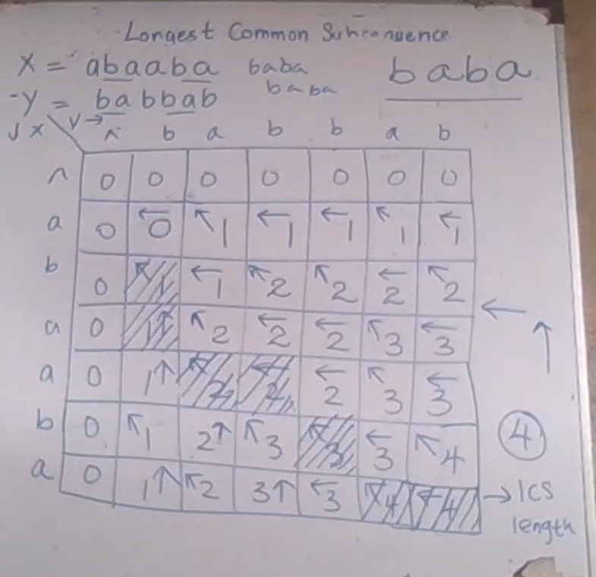

How to get the LCS

Pahalama slot eke idan arrows vala piliwelata slot paata karagena udatama yanna ona.ethenadi api LCS eka vidiyata ganne diagonal arrow eka thiyena slots valata adala characters.

LCS is – baba

**LINEAR PROGRAMMING PROBLEM FORMULATIONS**

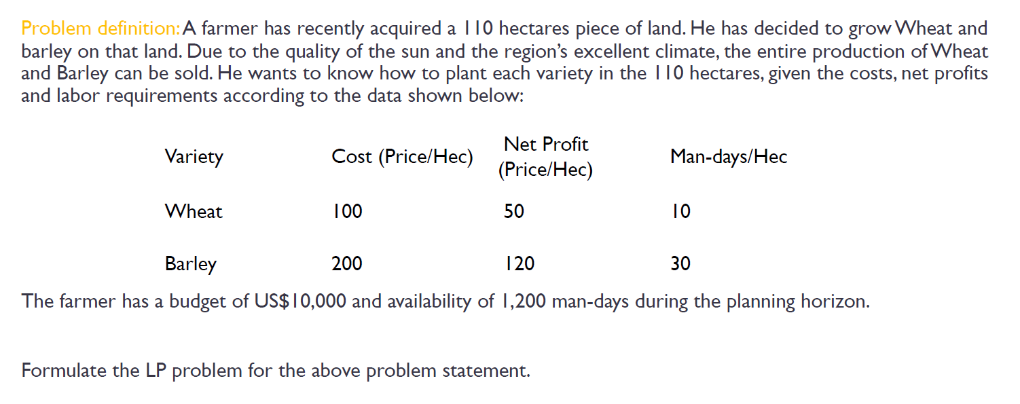

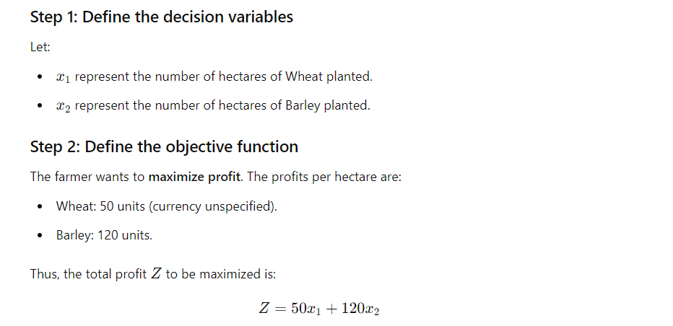

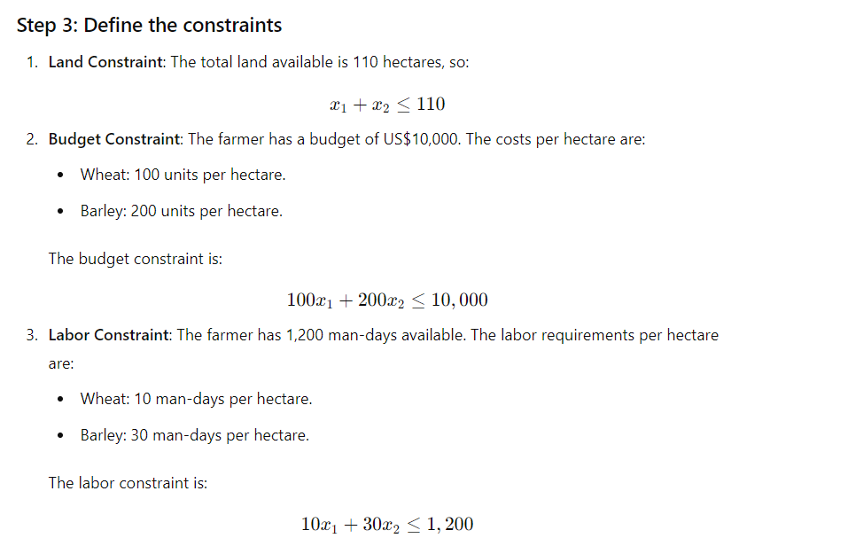

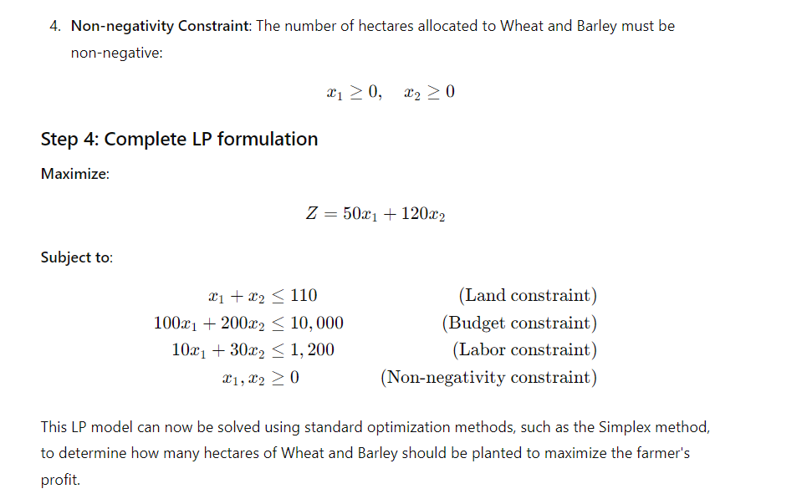

**LP FULL PROBLEM**

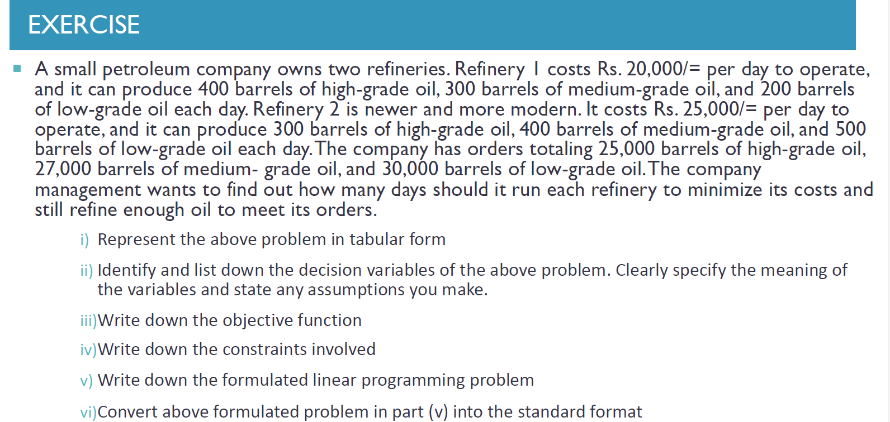

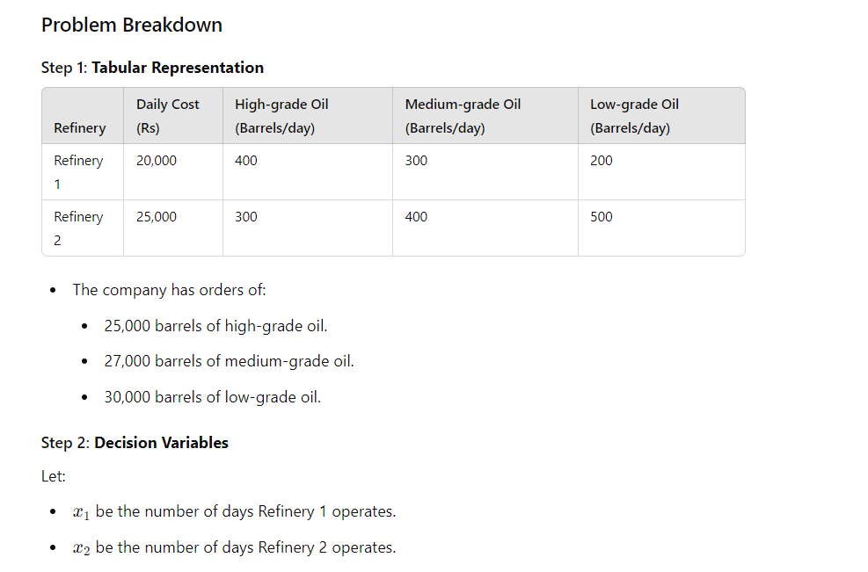

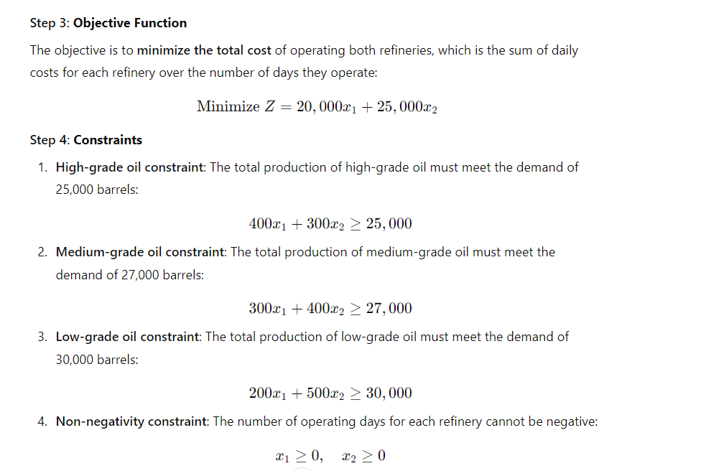

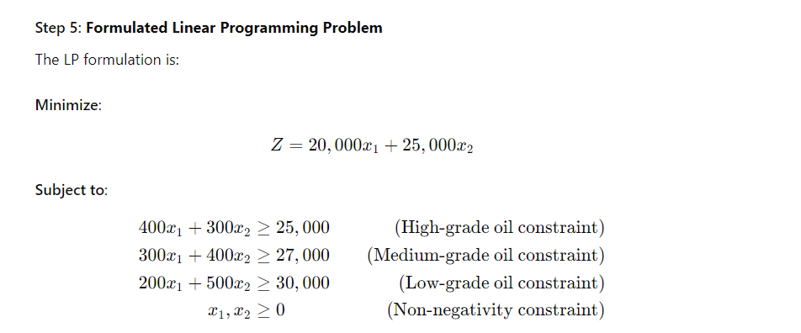

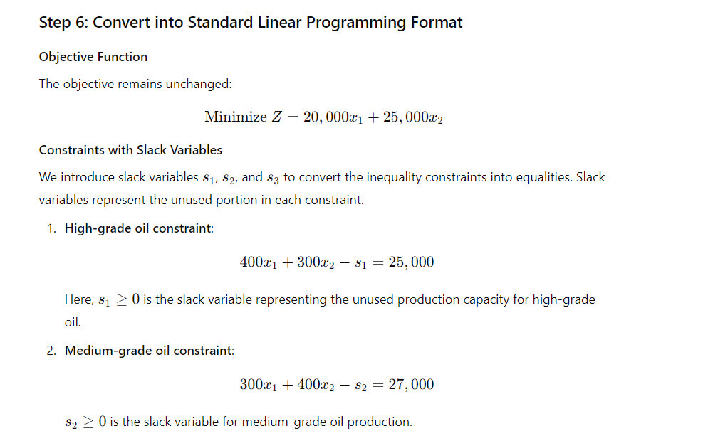

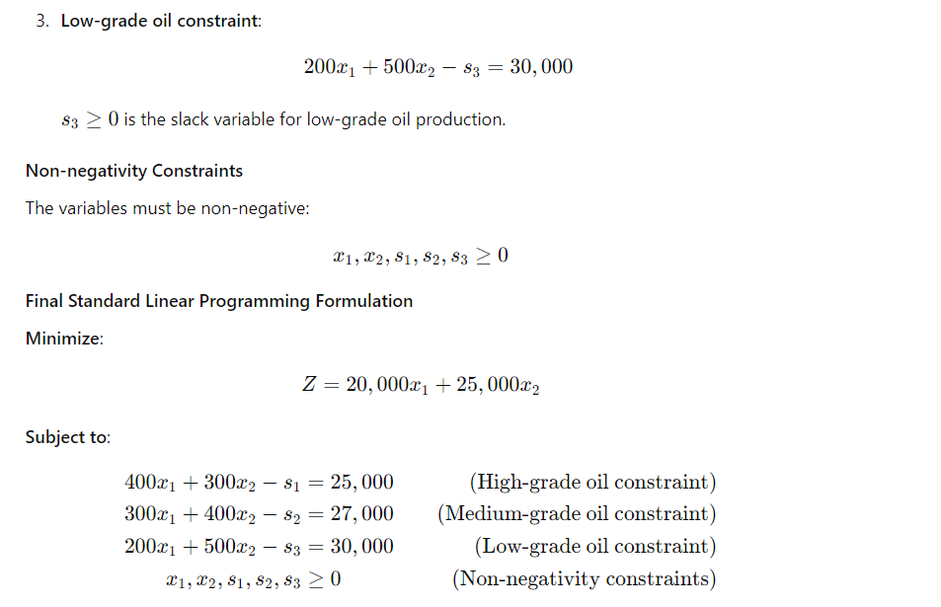

**LP FULL QUESTION IN GRAPHICAL METHOD**

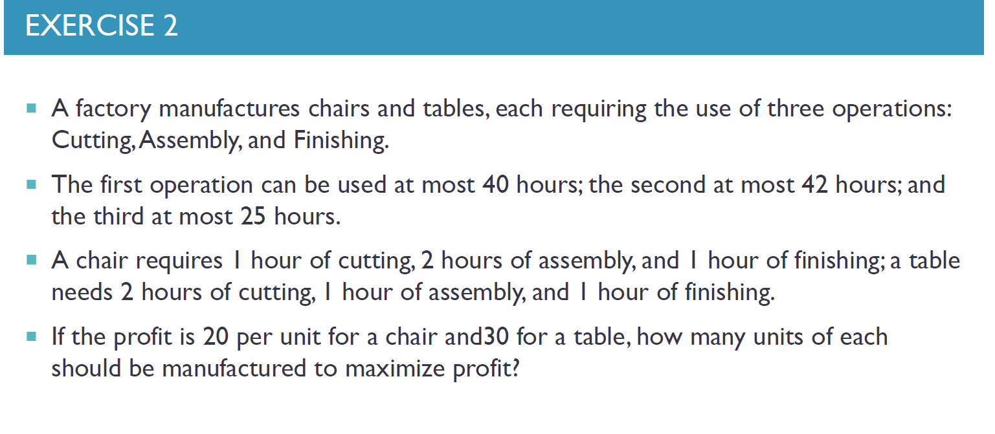

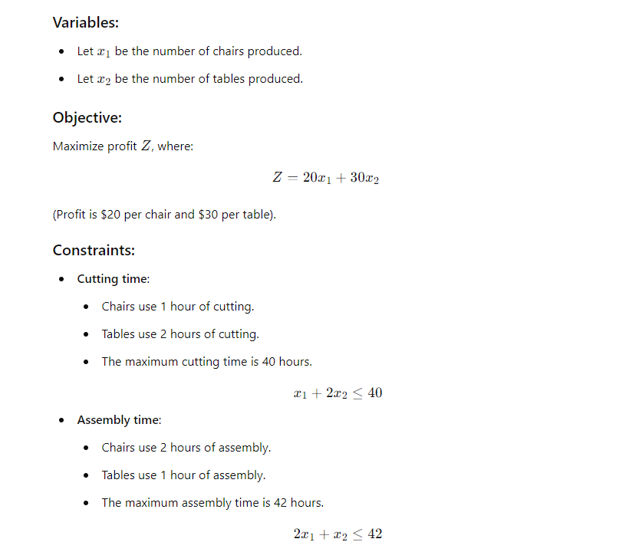

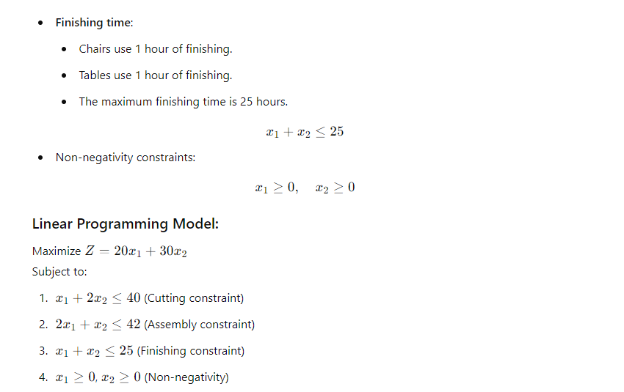

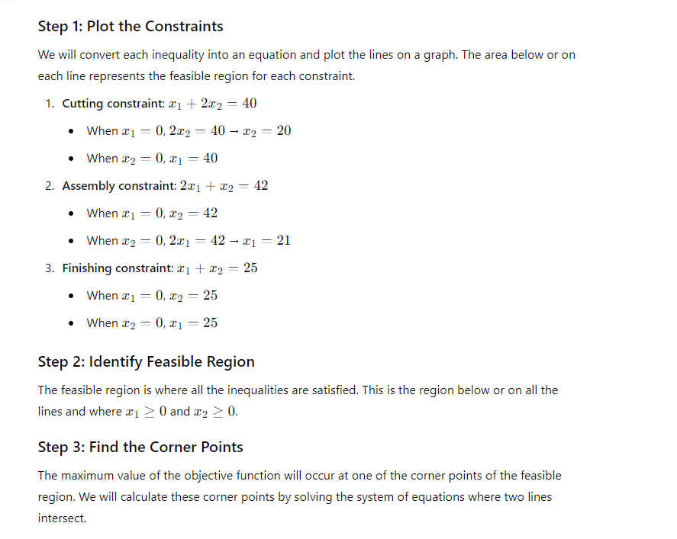

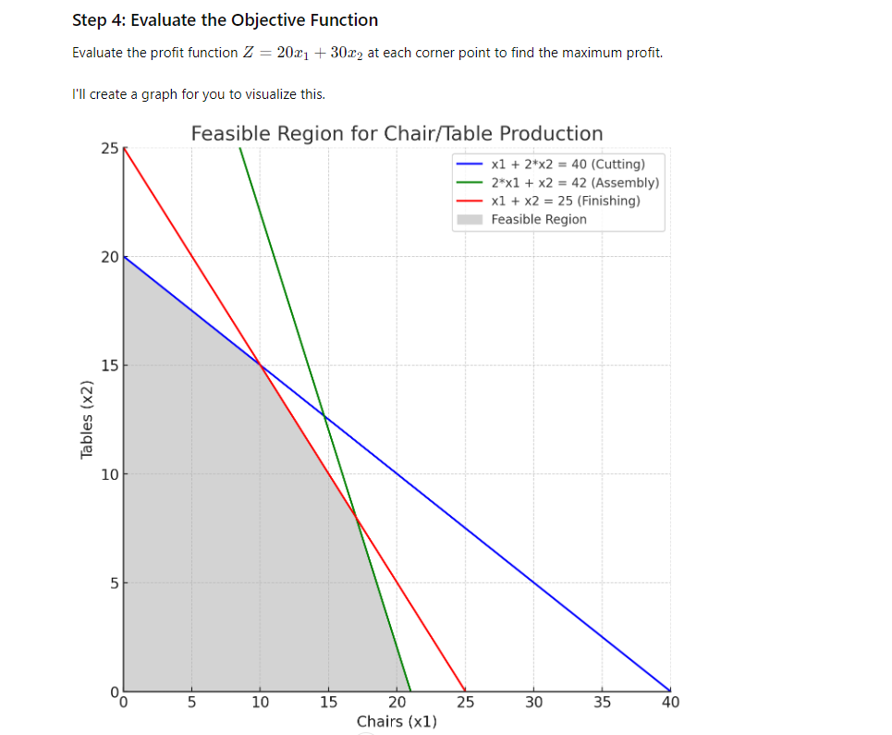



* 1. **Intersection of Cutting and Finishing constraints**:

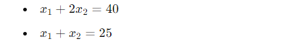

* 1. **Intersection of Assembly and Finishing constraints**:

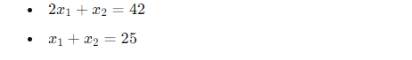

* 1. **Intersection of Cutting and Finishing constraints:**

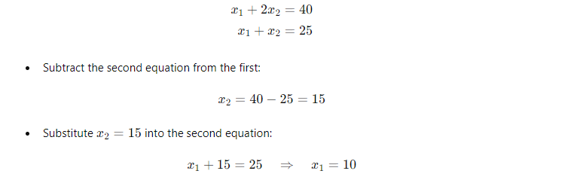

So,the first intersection point is (x1,x2)=(10,15).

**2 Intersection of Assembly and Finishing constraints:**

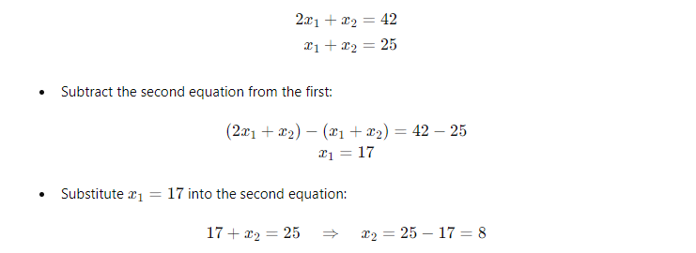

Second intersection point is (x1,x2)==(17,8).

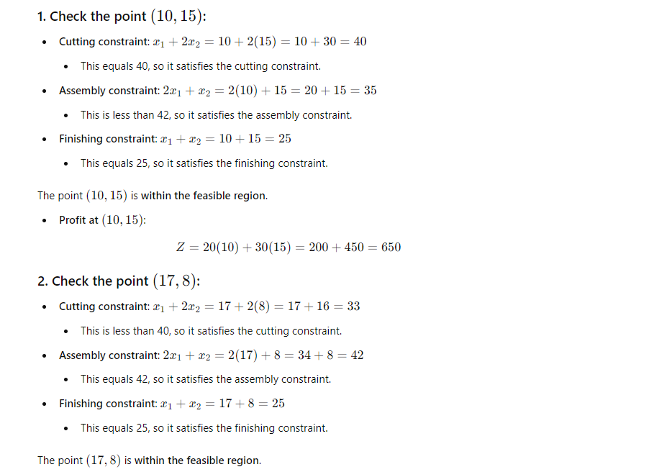

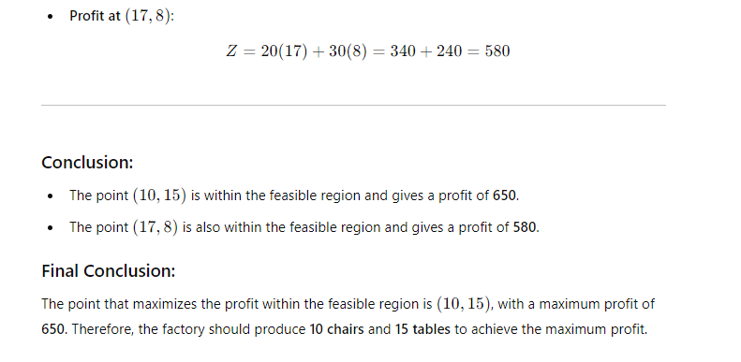

**SIMPLEX METHOD**

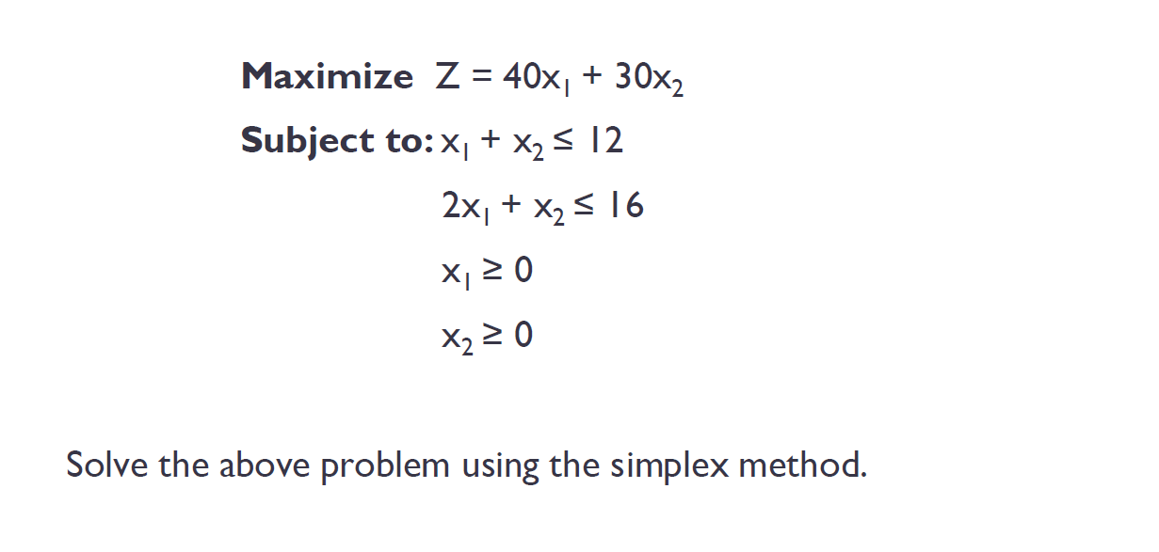

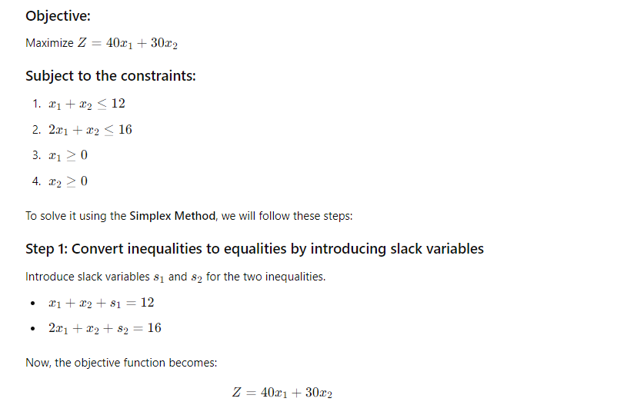

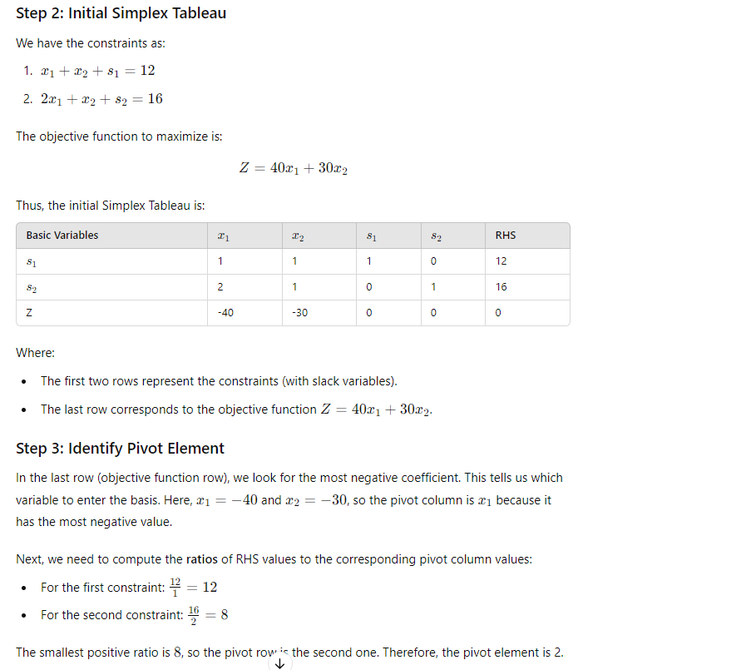

Z=40x1 + 30x2 => Z-40x1-30x2=0

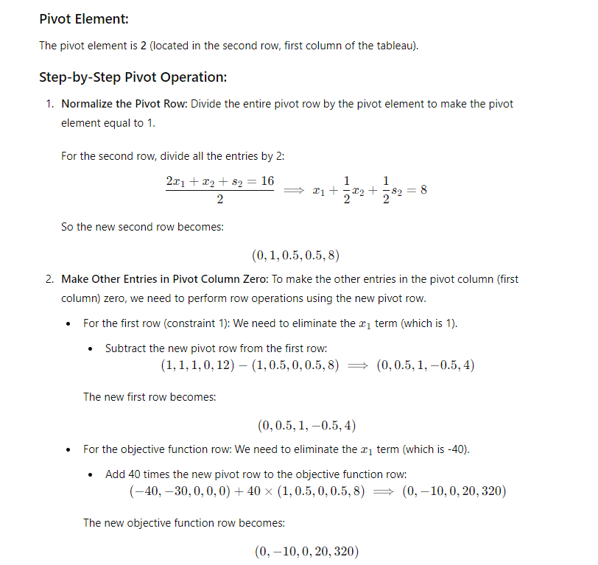

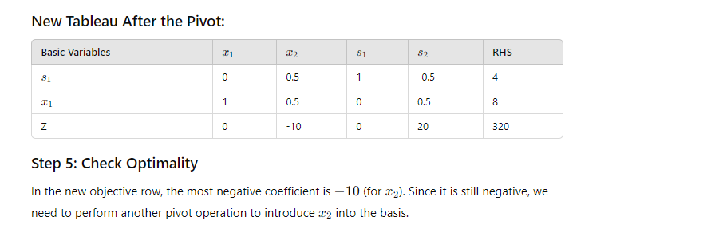

**This method can only use in maximization problems.in the minimization problems we want to use dual primal method.**

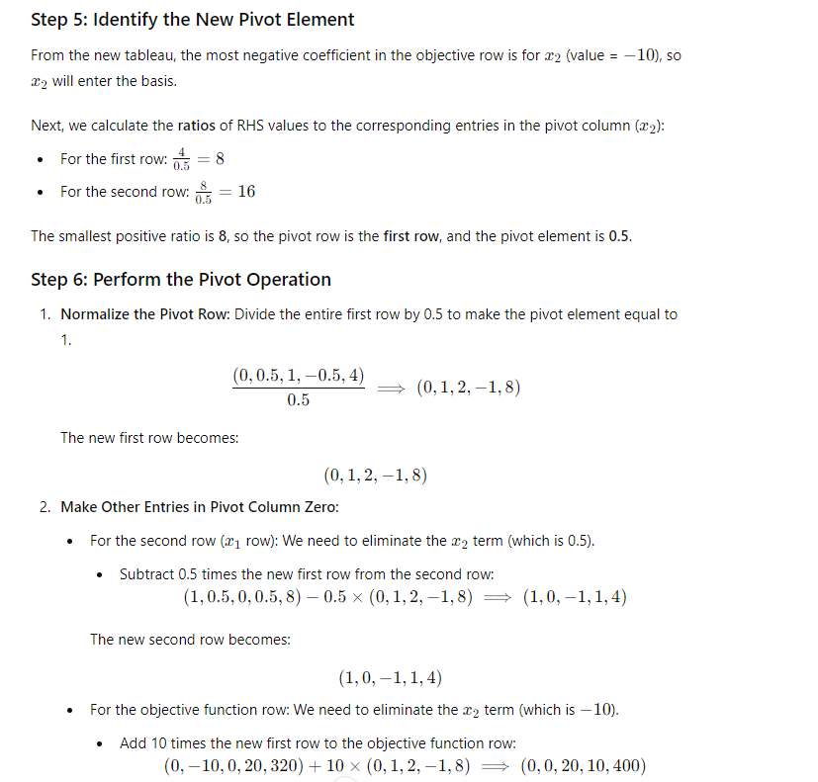

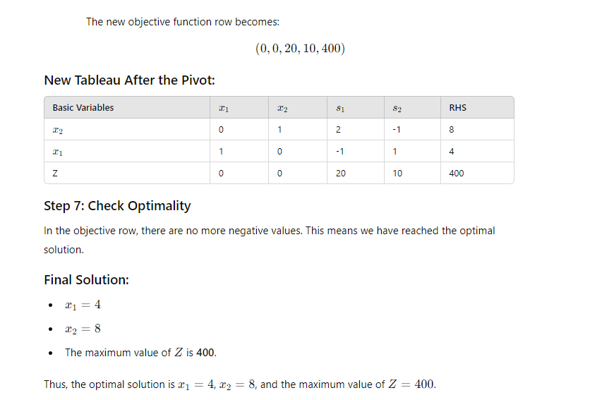

**Residual network,Augmenting path,Residual capacity**

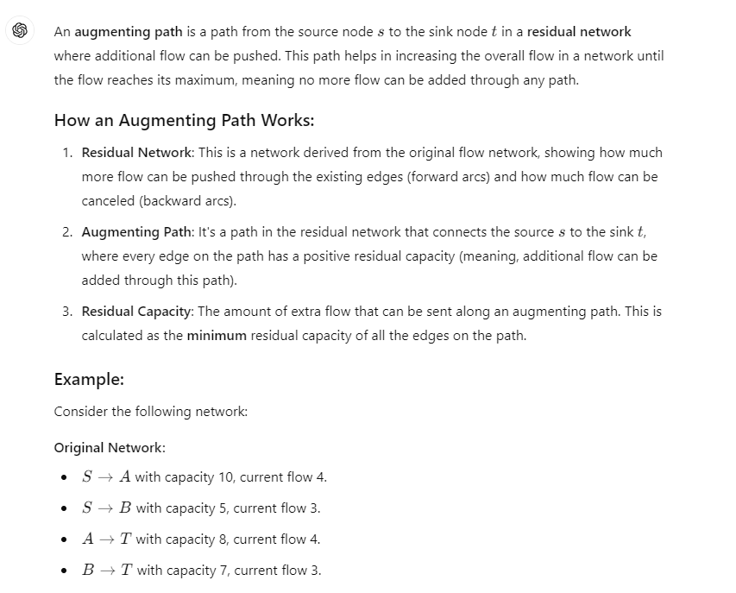

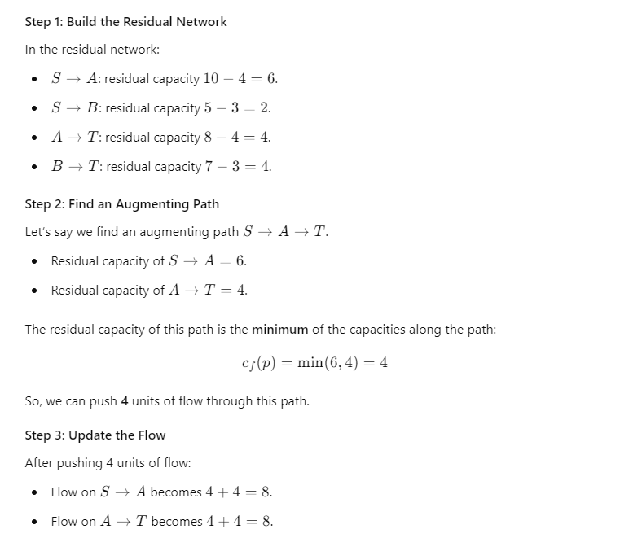

### Summary:

* An augmenting path allows increasing the flow in the network by finding paths in the residual network.
* The flow is increased by the minimum residual capacity along that path.

**Why choose S->A->T as the Augmenting path.not choosing S->B->T. Give reasons**

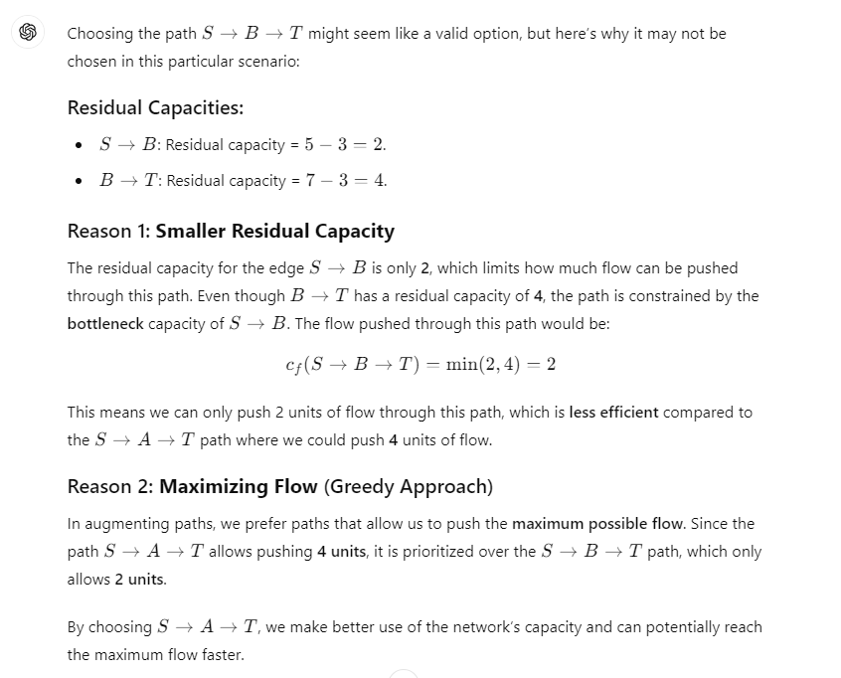

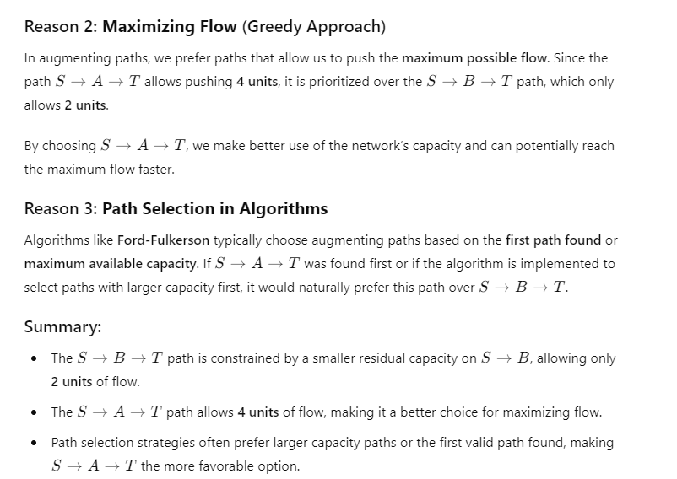

**MAXIMUM FLOW**

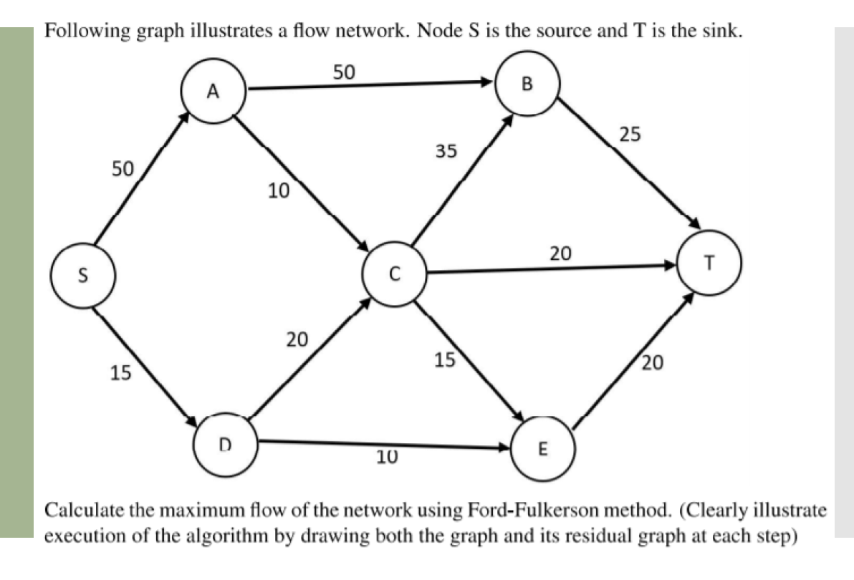

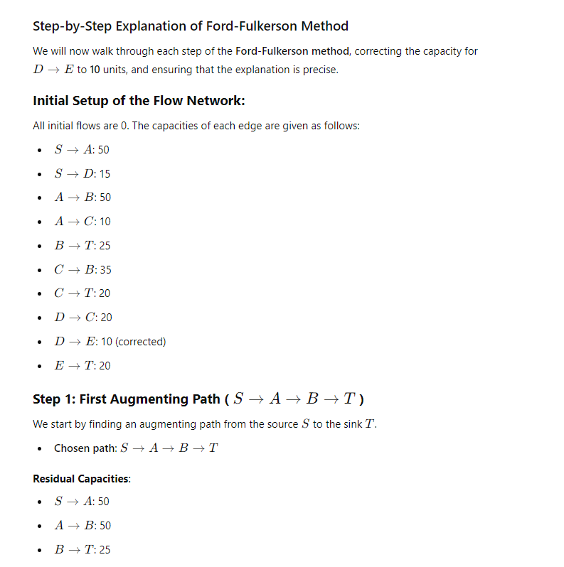

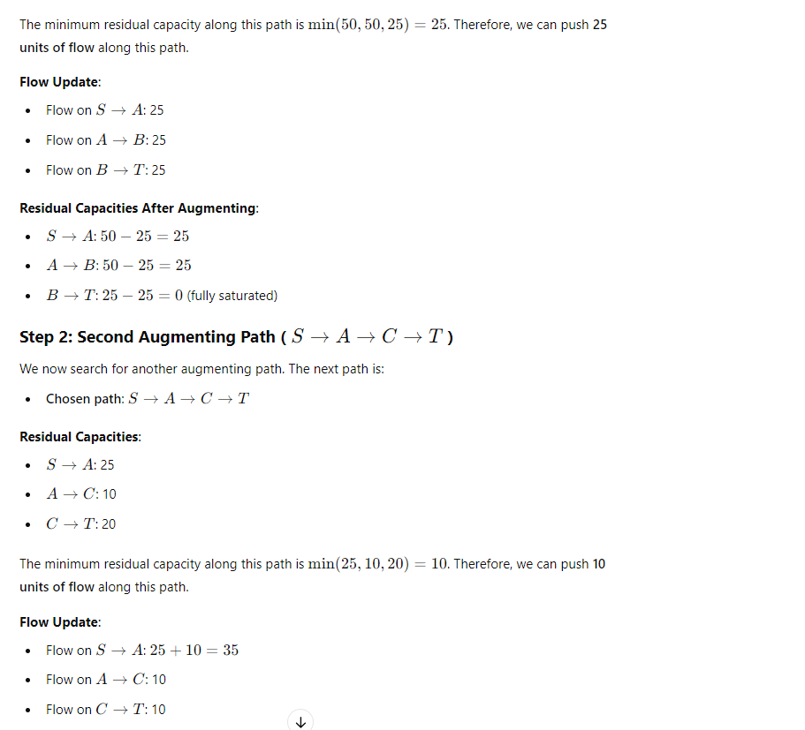

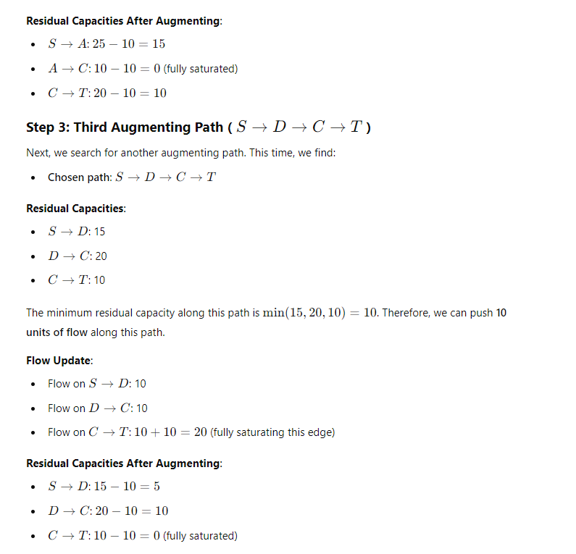

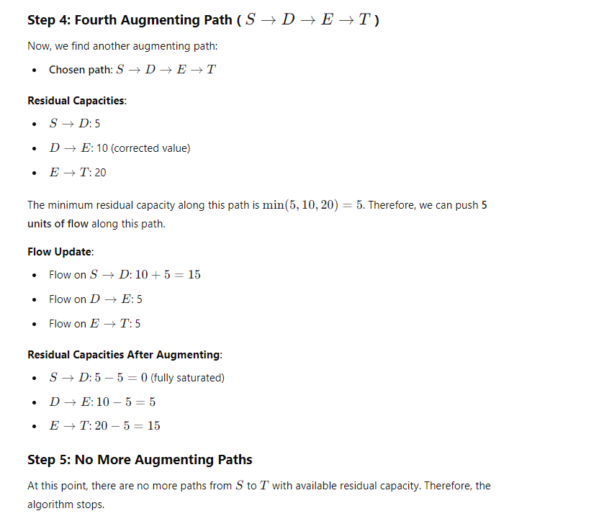

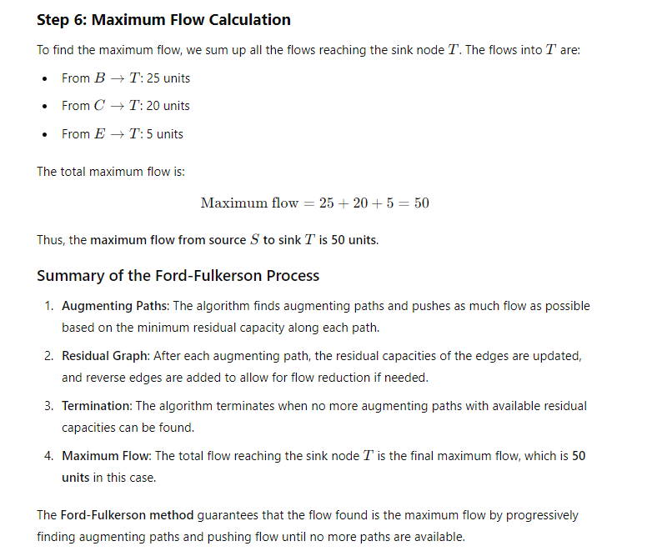

**Important:-**

**C->T become 20 by 10+10 in adition by two paths**

**Briefly describe linear programming listing the four main components.**

• **Decision Variables**: These represent the quantities that are to be determined in the problem.

• **Objective Function**: This is the function that needs to be optimized (maximized or minimized).

• **Constraints**: These are the restrictions or limitations on the decision variables, typically in the form of linear inequalities or equalities.

• **Non-negativity Constraints**: These are restrictions ensuring that the decision variables cannot take negative values.

**IMPORTANT**

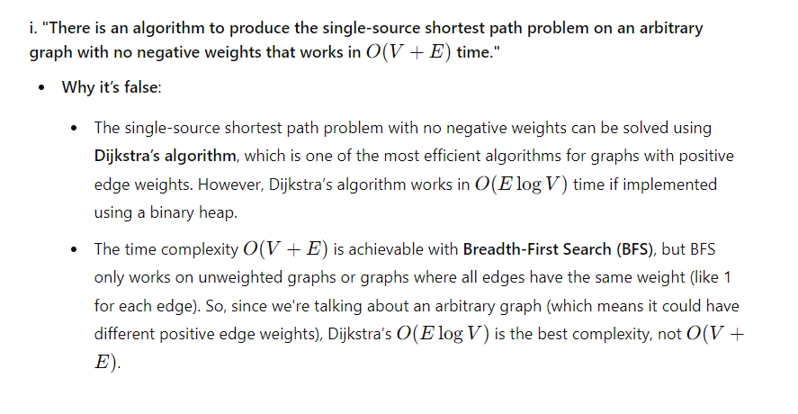

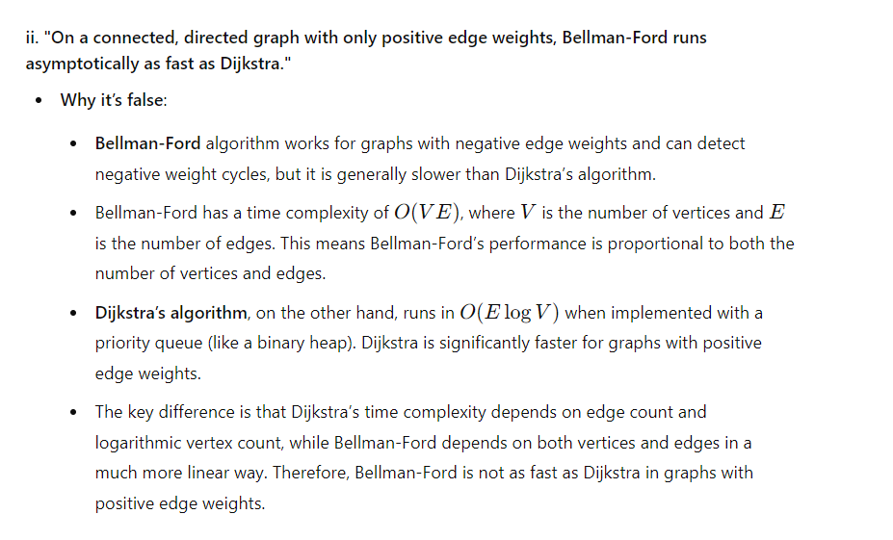

**Consider that the priority queue in Dijkstra’s algorithm is implemented using a sorted linked list (i.e., the list is kept sorted after each priority queue operation). Analyze the runtime of Dijkstra’s algorithm based upon this linked list implementation.**

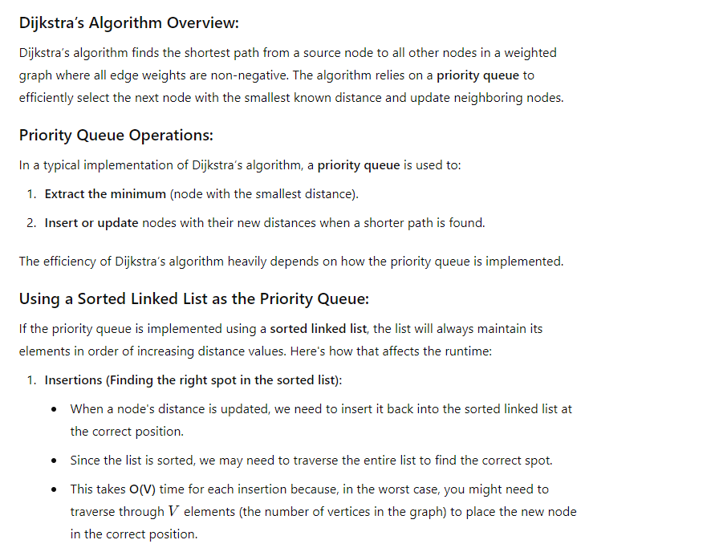

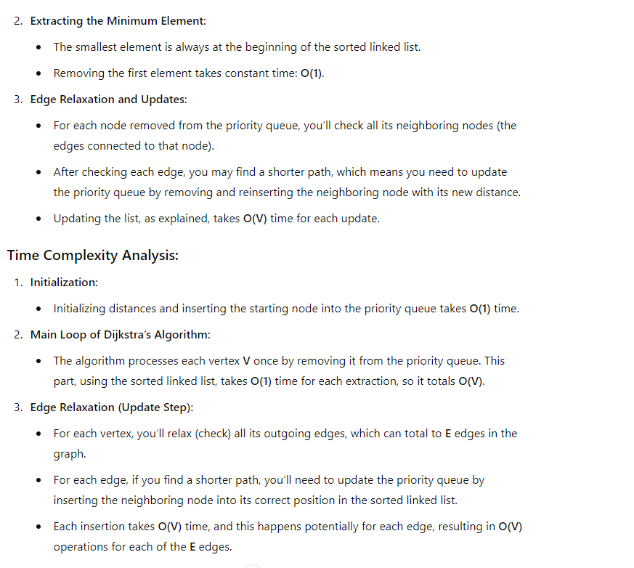

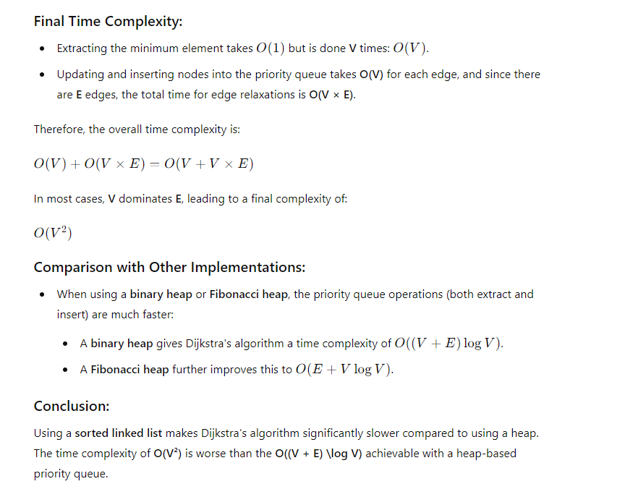

**STATEMENTS CORRECT OR INCORRECT**

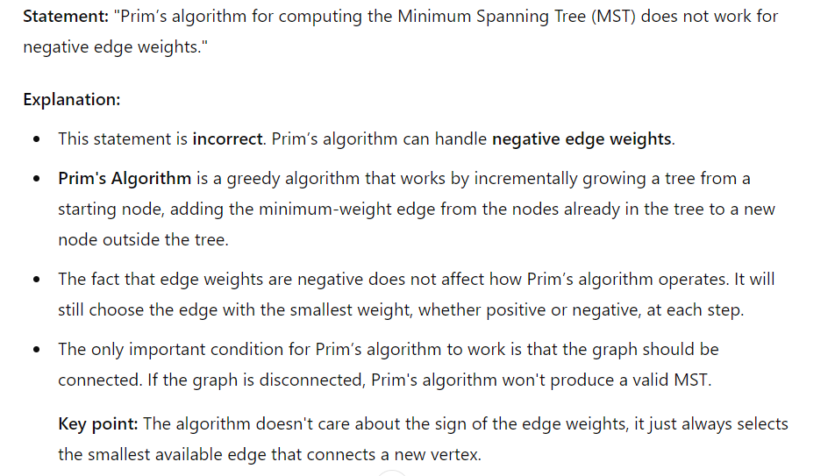

**TIME COMPLEXITY FINDING**

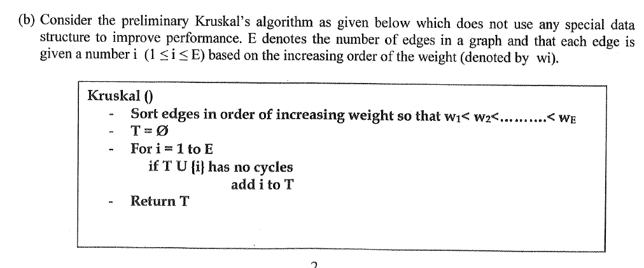



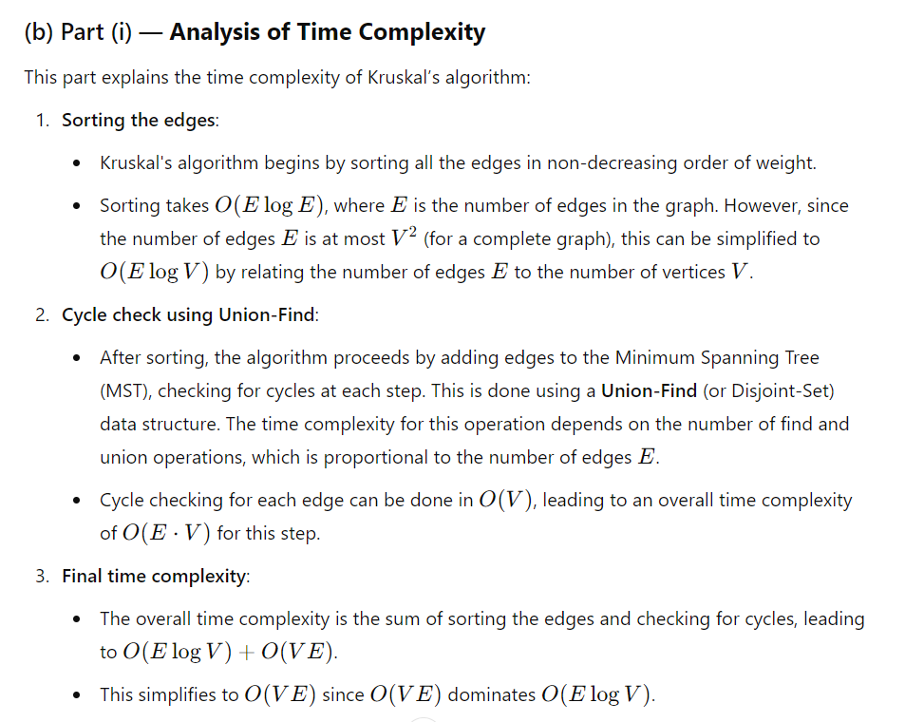

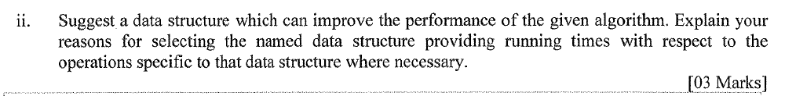

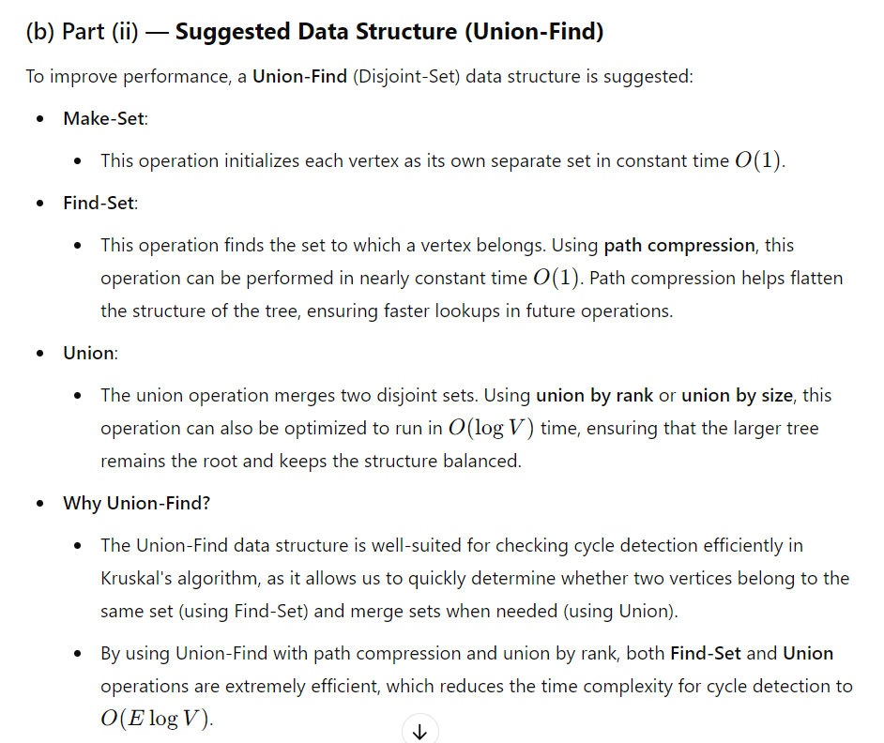

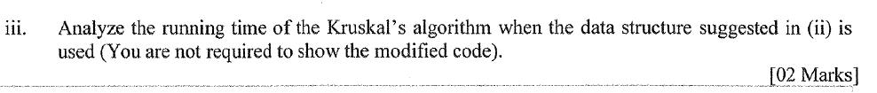

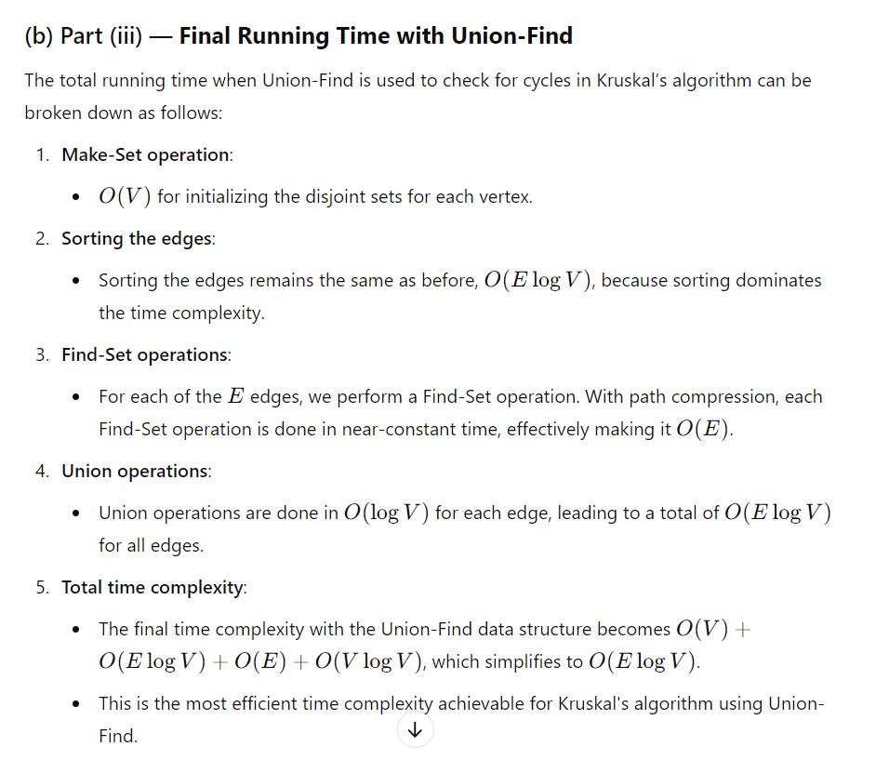

**Prim's and Kruskal's algorithms will always return the same Minimum Spanning tree.is this true or false.**

The statement that **Prim's and Kruskal's algorithms will always return the same Minimum Spanning Tree (MST)** is **false**.

Both Prim's and Kruskal's algorithms **guarantee finding a Minimum Spanning Tree**, but they do **not necessarily return the same exact tree**. Here's why:

### Key Differences:

1. **Prim's Algorithm**:
   * **Approach**: Greedy algorithm that grows the MST from an initial starting vertex, always adding the least expensive edge that connects a vertex in the tree to a vertex outside the tree.
   * **Graph type**: It works best on dense graphs (where there are many edges), but it can be applied to any connected graph.
2. **Kruskal's Algorithm**:
   * **Approach**: Greedy algorithm that adds edges in order of increasing weight, as long as they do not form a cycle. It doesn't build from a particular starting node.
   * **Graph type**: Works best on sparse graphs (fewer edges), but it can also be applied to any connected graph.

### When They Can Return Different Trees:

* **Non-Unique MSTs**: If the graph has edges with **equal weights**, there may be **more than one valid MST** for the same graph. Since both algorithms work in a different manner (Prim's grows a tree incrementally, while Kruskal's selects edges globally), they may choose different edges and form **different MSTs**.
* **Graph Structure**: The **order of edges or vertices** chosen by the algorithms can vary depending on how they explore the graph. This can lead to different spanning trees, though both will have the same total weight.

### When They Return the Same Tree:

* If the graph has **distinct edge weights**, then there is only **one unique MST**, and both algorithms will return the same result.

### Example:

Consider the following graph:

Vertices: {A, B, C}

Edges:

- (A, B) with weight 1

- (B, C) with weight 2

- (A, C) with weight 1

* **Kruskal's Algorithm** might select edges (A, B) and (A, C) since they have the smallest weights.
* **Prim's Algorithm** might start from vertex A, select (A, B) first, and then add (B, C) (ignoring A, C).

Both algorithms will return valid Minimum Spanning Trees, but **the trees can be different**.

### Conclusion:

Prim's and Kruskal's algorithms will always return an MST, but **not necessarily the same MST** unless the graph has a unique solution (like when all edge weights are distinct).

**Minimum spaning tree question**



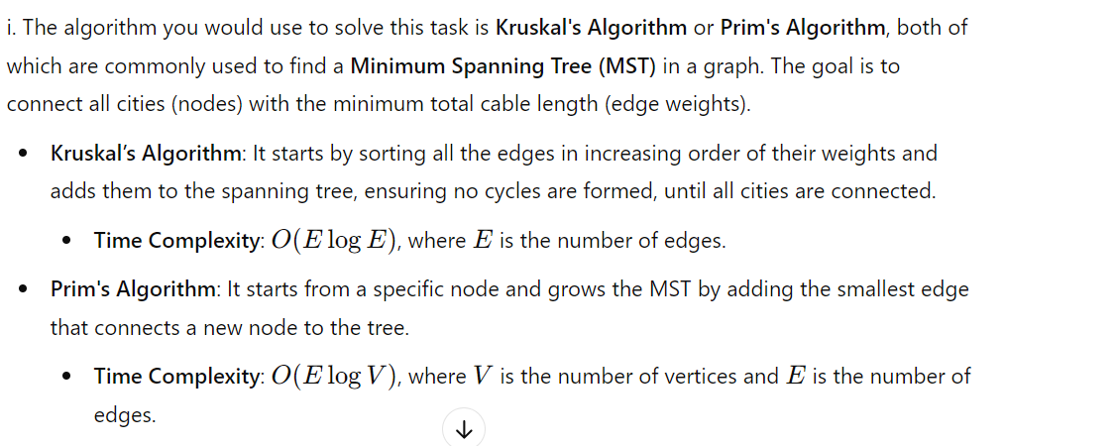

### 

### Step-by-Step Application of Kruskal’s Algorithm

#### **Step 1: Sort the Edges by Weight**

We start by sorting all edges in ascending order of their weights:

1. **34** (City D - City C)
2. **40** (City A - City C)
3. **45** (City E - City G)
4. **50** (City B - City E)
5. **60** (City F - City H)
6. **68** (City D - City B)
7. **70** (City A - City B)
8. **72** (City F - City G)
9. **75** (City D - City F)
10. **83** (City C - City H)
11. **85** (City G - City H)

Also we want to choose A -> D to determine X value

**IF we choose first A->C we cannot add A->D. because this makes a cycle.therefore A->D should be less than 40 and greater that 34.**

**34<X<40**

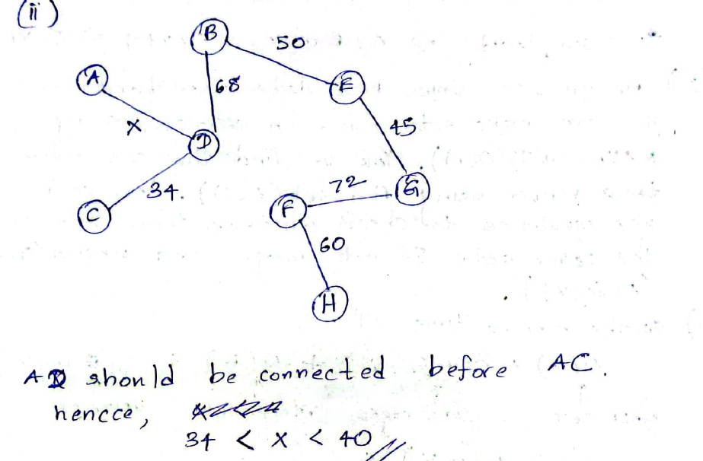

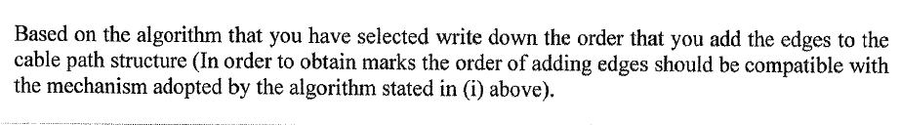



**Bellmon Ford algorithm**



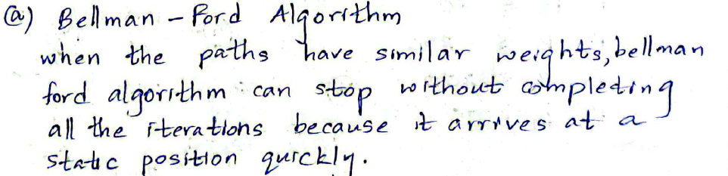

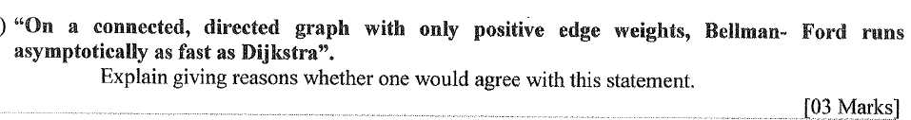

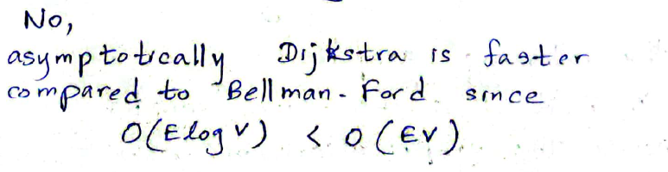

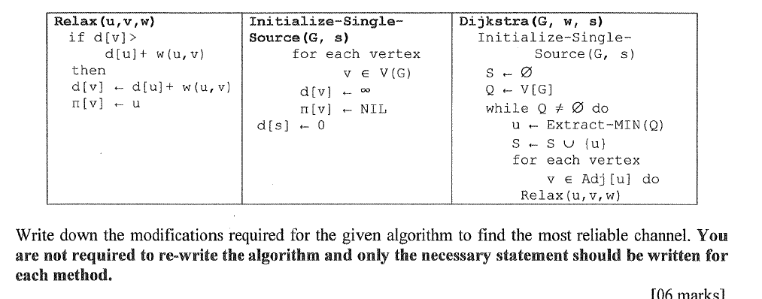

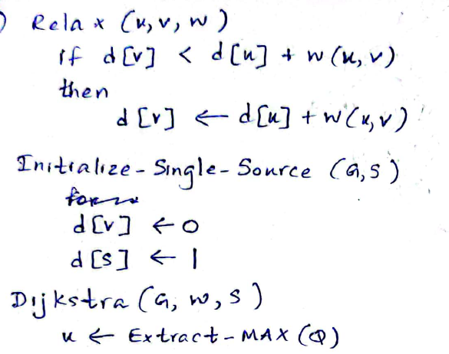

**Huffman coding**

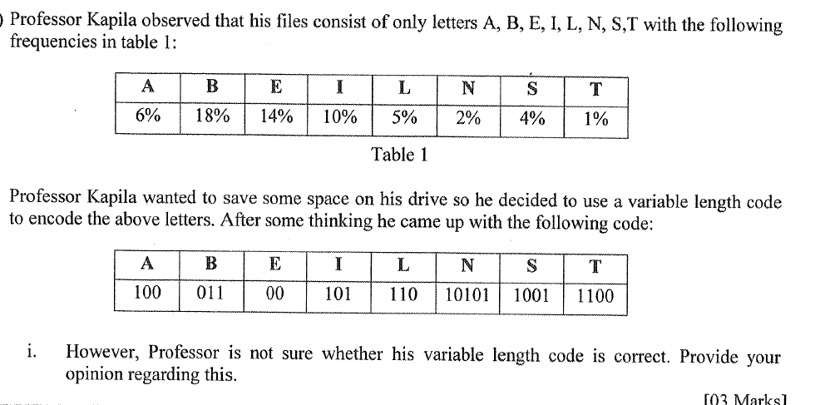

To determine if Professor Kapila's variable-length code is correct, we need to verify two main things:

1. **Prefix-Free Property**: No code in the set should be a prefix of any other code. This ensures that the encoding can be uniquely decoded (no ambiguity).
2. **Huffman Coding Suitability**: If the professor is trying to minimize the average length of the encoded message, the code should resemble something like Huffman coding, which assigns shorter codes to more frequent letters and longer codes to less frequent letters.

#### Step 1: Check the Prefix-Free Property

Let's examine the variable-length code for each letter:

* A: 100
* B: 011
* E: 00
* I: 101
* L: 110
* N: 10101
* S: 1001
* T: 1100

We need to check if any code is a prefix of another. Here's a quick check:

* A (100) is a prefix of S (1001), which violates the prefix-free condition.

Since A's code is a prefix of S's code, **this encoding is not correct**. It would lead to ambiguity in decoding, as there would be confusion when encountering "100" — it could either mean "A" or part of the code for "S".

#### Step 2: Huffman Coding Suitability

The professor's goal seems to be space-saving, and the frequencies in Table 1 suggest the use of Huffman coding. In Huffman coding:

* Higher frequency letters should have shorter codes (e.g., B: 18%, E: 14%).
* Lower frequency letters should have longer codes (e.g., N: 2%, T: 1%).

However, the given encoding does not follow this principle. For example:

* N, which has a low frequency of 2%, has a code of 10101, which is acceptable (longer code for a lower frequency).
* But T, which has the lowest frequency (1%), has the relatively short code 1100, which is inconsistent with the optimality of Huffman coding.

#### Conclusion:

* The **prefix-free property is violated**, so the code is not uniquely decodable.
* The code lengths do not fully reflect the frequency distribution, meaning it is not optimized for space-saving either.

Therefore, Professor Kapila's variable-length code is **incorrect** and should be revised to ensure it is both prefix-free and better suited for minimizing space (potentially through Huffman coding).

**ii. Construct a Huffman code for the characters in table 1.**



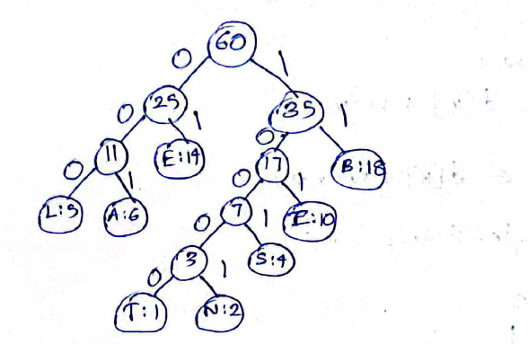

T – 1 – 10000

N – 2 – 10001

s-4- 1001

L- 5 – 000

A – 6 – 001

i - 10 – 101

E- 14- 01

B – 18 - 11



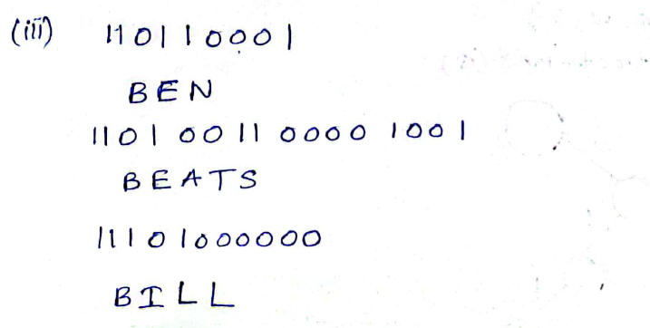

**Maximum flow question**

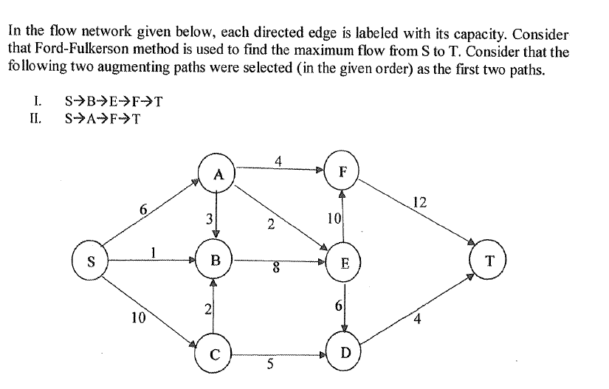

### ****Flow Network and Residual Network After Augmentation****

1. **First augmenting path: S -> B -> E -> F -> T**
   * **Flow along this path**: The minimum capacity along this path is 1 (S -> B).
   * **Updated capacities**:
     + S -> B: 1 → 0
     + B -> E: 8 → 7
     + E -> F: 10 → 9
     + F -> T: 12 → 11
   * **Residual capacities**:
     + B <- S: 1
     + E <- B: 1
     + F <- E: 1
     + T <- F: 1
2. **Second augmenting path: S -> A -> F -> T**
   * **Flow along this path**: The minimum capacity in this path is 4 (A -> F).
   * **Updated capacities**:
     + S -> A: 6 → 2
     + A -> F: 4 → 0
     + F -> T: 12 → 8
   * **Residual capacities**:
     + A <- S: 4
     + F <- A: 4
     + T <- F: 4

### (b) ****Augmenting Paths for the Third Augmentation Step****

After the first two augmentations, these are the possible paths based on the residual network:

1. **S -> C -> D -> T**
   * Path capacity: 4 (limited by D -> T).

### (c) ****Calculate the Maximum Flow Using the Ford-Fulkerson Algorithm****

Let’s assume the third augmenting path selected is **S -> C -> D -> T**, with a flow of 4.

1. **Third augmenting path: S -> C -> D -> T**
   * **Flow along this path**: The minimum capacity is 4 (D -> T).
   * **Updated capacities**:
     + S -> C: 10 → 6
     + C -> D: 5 → 1
     + D -> T: 4 → 0
   * **Residual capacities**:
     + C <- S: 4
     + D <- C: 4
     + T <- D: 4

### Final Calculation of Maximum Flow

After augmenting through three paths, the maximum flow is the sum of the flows along these paths:

1. **First augmenting path**: S -> B -> E -> F -> T (Flow = 1 unit)
2. **Second augmenting path**: S -> A -> F -> T (Flow = 4 units)
3. **Third augmenting path**: S -> C -> D -> T (Flow = 4 units)

Thus, the **maximum flow = 1 + 4 + 4 = 9 units**.

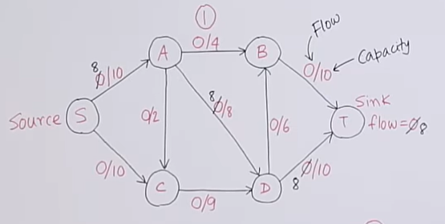**Ford Flukerson algorithm for maximum flow problem**

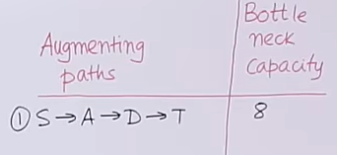

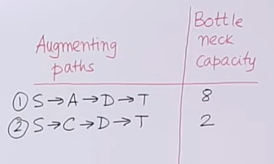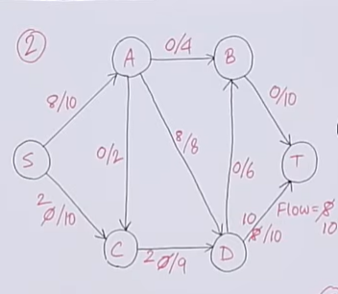

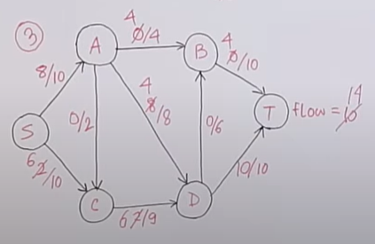 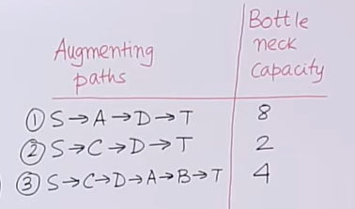

* DA edge is in A->D direction.but we considering path it is on D->A direction.then we want to substract 4 from the 8.(if we think we get AD in A->D direction.also we cannot get that because it is full of capacity (8/8).).this substract method is called backtracking.

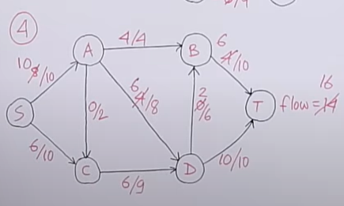 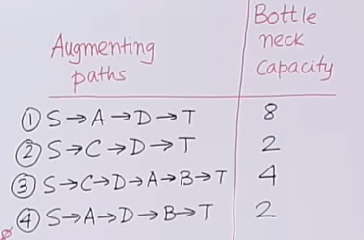

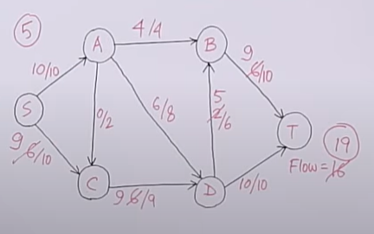 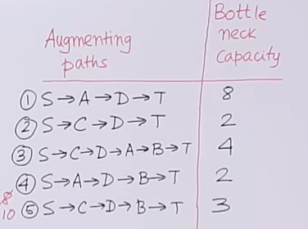

**KMP and BM algorithms difference**

**1.**

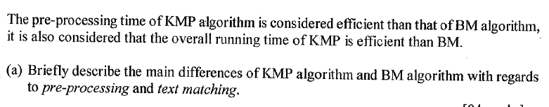

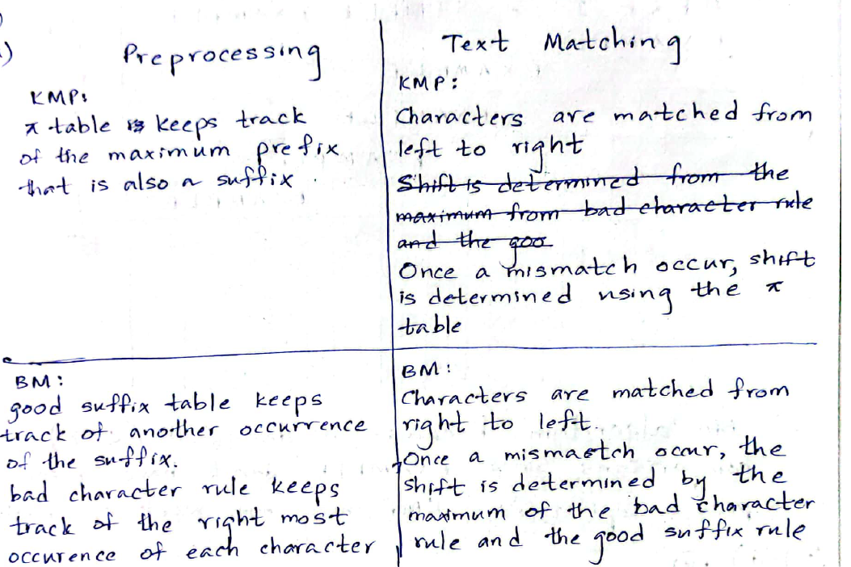

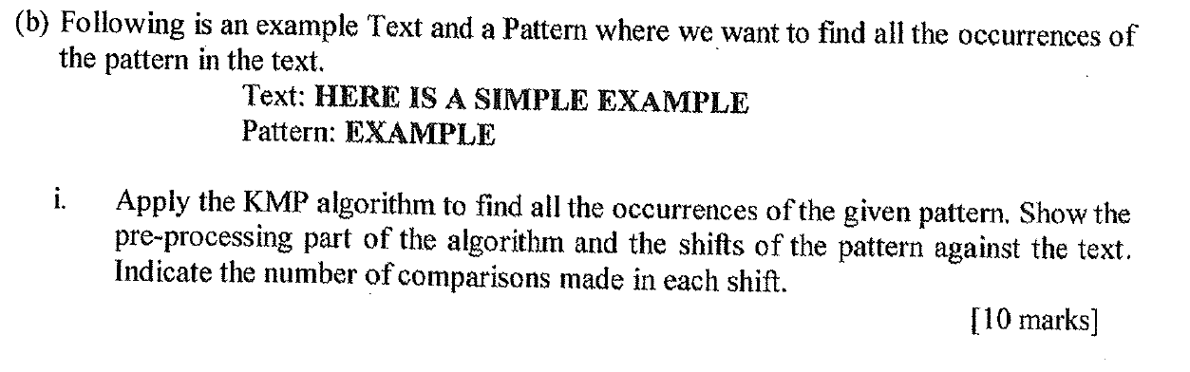

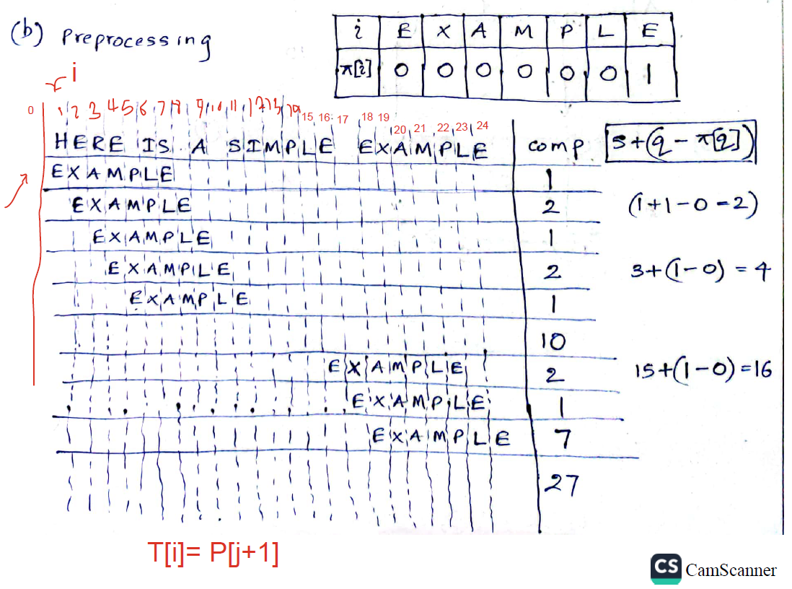

Meke mulinma H,E denna samanada balanawa.samana nathi nisa j inna thana current pi value ekata move karanna ona.namuth ethana pi value ekak nathi nisa i E valata maru karanawa.dan aima E(j+1),E(i) samanada kiyala balanawa.e check karana peliya thamai 2 veni peliya.mul peliye check kare H,E samanada kiyala vitarai.e nisa comparisons 1.deveni peliye E,E check karala eeta passe R,X check karana nisa comparisons 2.hamathissema check karana letters 2 eka yata eka thiyana vidiyata thamai pahalata liyagena yanne.

**(ii) BM algorithm**

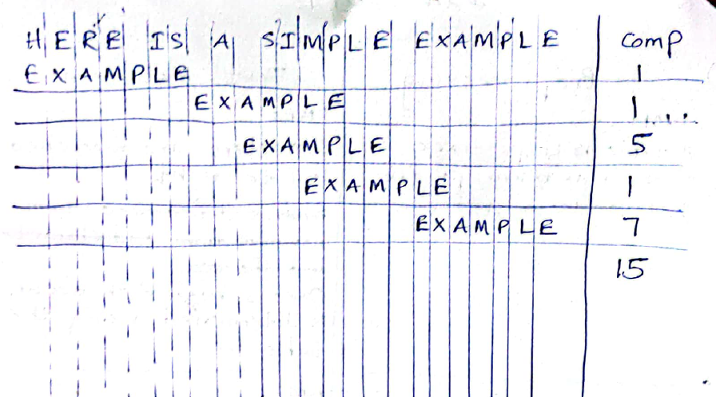

**(iii)**

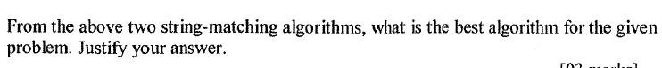

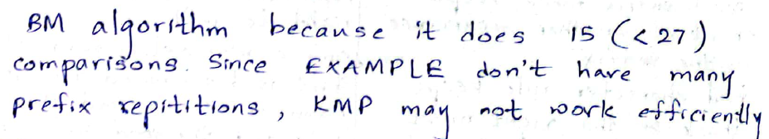

**2.**

**(i)**

**KMP algorithm**

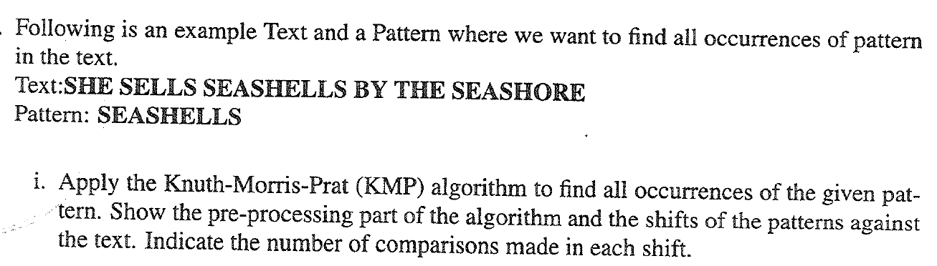

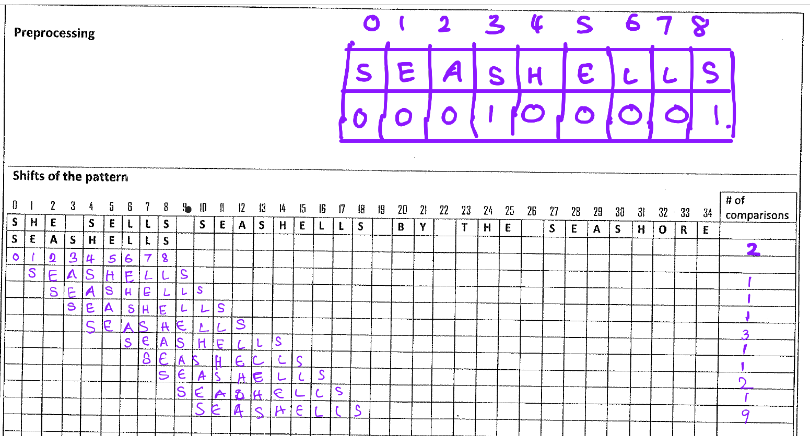

**(ii)**

**Boyer moyer Horspool**

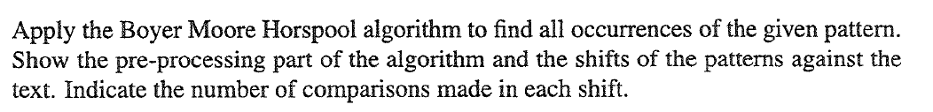

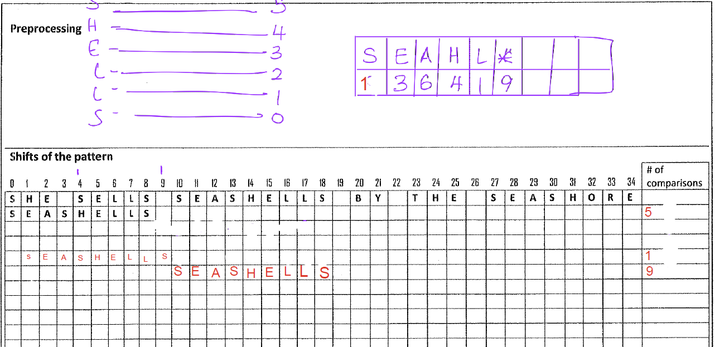

**Total comparisons = 15**

**Me pattern ekedi api mulinma pre processing vidiyta pattern eke thiyana elements tika mula idan anthima venakam distinct vidiyata table ekata add karagannawa.pattern eka index venne 0 idan issarahata.**

**Mul element eka S pattern eke.api me formula eka use karanawa adala field eka fill karanna.**

**Table value=max(1,(pattern len.-current element pattern index-1))**

**First attempt S field value= max(1,(9-0-1)=max(1,8)=8**

**E=> max(1,(9-1-1)=7**

**A=>max(1,(9-2-1)=6**

**S=>>max(1,(9-3-1)=5**

**H=>max(1,(9-4-1)=4**

**E=>max(1,(9-5-1)=3**

**L=>max(1,9-6-1)=2**

**L=> max(1,9-7-1)=1**

**(*) represent any other element.its field value is pattern length**

**=9**

**Pattern matching part**

**Me pattern ekedi api text eke right side eke idan balagena yanawa bad character ekak hambenakam.mulinma hambenne S.eeta passe ekata adala table field value eken pattern eka shift karanawa(1 shift).**

**Eeta passe mul ekama bad ekak.eke field value eka 9.pattern eka index 9 shift karanawa.**

**Dan pattern eka match venawa.**

**\*Shift karanna ona gana text eka 0 idan issarahata index karama me formula eken gannath puluwan.**

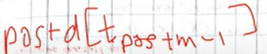

**pos=> comparing text index**

**m=>pattern length**

**d[t pos+m-1]=> relavant index letter table value**

**t pos+m-1 => index of letter to get the value from table**

**(iii)**

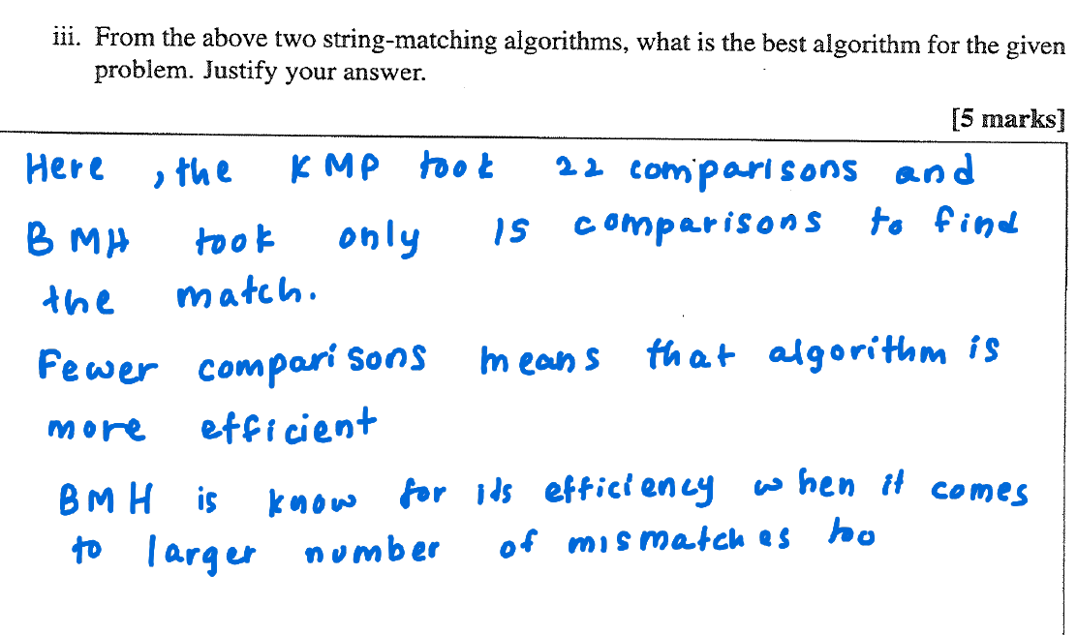

**Bad character and good suffix combine better explain**

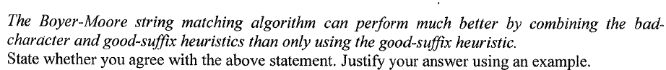

Yes, I agree with the statement that the Boyer-Moore string matching algorithm performs better when combining the bad-character and good-suffix heuristics compared to using only the good-suffix heuristic. Here's why:

The **bad-character heuristic** allows the algorithm to skip over mismatched characters by shifting the pattern to the right based on the last occurrence of the mismatched character in the pattern. The **good-suffix heuristic**, on the other hand, shifts the pattern based on matching suffixes, allowing jumps over sections of the pattern.

When both heuristics are combined, they allow the algorithm to make more significant jumps, resulting in fewer character comparisons and better performance overall. If only the good-suffix heuristic is used, the shifts are solely based on suffix matches, potentially leading to smaller jumps, which increases the number of comparisons needed.

**Example:**

Consider the text "ABAAABCD" and the pattern "ABC".

* **Bad-character heuristic**: After comparing the pattern with the text and encountering a mismatch, the algorithm can skip characters that do not appear in the pattern.
* **Good-suffix heuristic**: When a suffix of the pattern matches but there's a mismatch before the suffix, the algorithm shifts the pattern to align with the next occurrence of the suffix in the pattern.

When both heuristics are used together, the pattern can be shifted more aggressively, which reduces unnecessary checks and improves efficiency.

In contrast, using only the good-suffix heuristic would not take advantage of the bad-character rule, leading to more comparisons. Thus, combining both heuristics generally enhances the performance of the Boyer-Moore algorithm.

**Preprocessing In pattern matching**

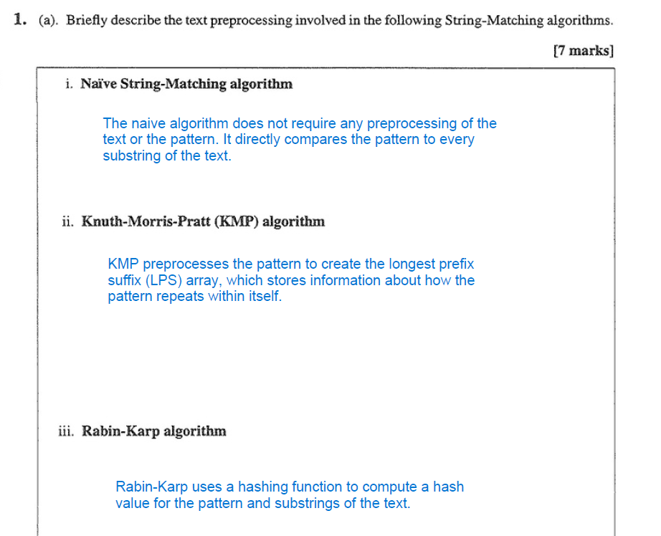

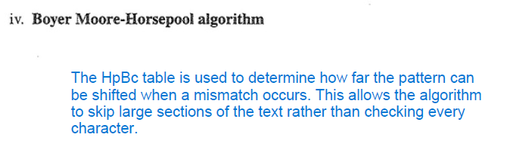

**Efficiency in pattern matching**

